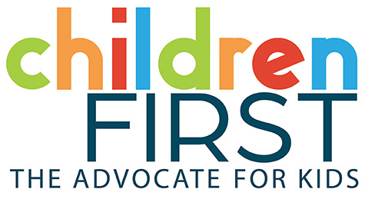


Supporting All Young Learners to Thrive:
Dismantling the Preschool to Prison Pipeline
Full Report

Report Brief available at: www.childrenfirstpa.org/dismantlingthepipeline

Table of Contents

Abstract: Page 3
Executive Summary: Page 4
Introduction: Page 6
Background: Exclusionary Discipline in ECE: Page 7
Methods and Analytic Approach: Page 9
- Surveys
- Focus Groups
- Classroom Observations
- Decision Tree Development
- Implementation Context

Summary of Key Results: Page 14
- Provider Surveys
- Family Surveys
- Focus Groups: Qualitative Findings
    - Family Perspectives
    - Provider Prosepctives
- Classroom Observations: Assessment & Professional Development (PD) Pilot Results

Promising Strategies from Other States: Page 29

Policy Roadmap for Reducing and Addressing Exclusionary Discipline in Pennsylvania: Page 31
- Short-Term Priorities (1–3 years)
- Long-Term Priorities (3–5 years)

Discussion and Implications: Page 36
- System Challenges

Implementation Considerations and Implications for Pennsylvania: Page 38
Conclusion: Page 39
Appendixes: Page 40
References: Page 62

Abstract

This report examines exclusionary discipline practices – including suspension, expulsion, and informal removals – in Pennsylvania’s early childhood education (ECE) system. These practices disproportionately impact Black children, Hispanic boys, and children with disabilities, reinforcing inequities that extend into later schooling. Using a mixed-methods design, the study combined provider and family surveys, focus groups, and classroom observations, alongside decision tree tools that model current realities and potential reforms.

Findings show that more than half of families surveyed experienced disenrollment without adequate support; providers reported limited use of state resources; training quality was inconsistent; and workforce instability undermined inclusive care. The report outlines a phased policy roadmap to reduce and address exclusionary discipline, emphasizing immediate family supports, statewide data tracking, and inclusion incentives, alongside long-term reforms in workforce stability, training, and service coordination.

Executive Summary
Exclusionary discipline in early childhood education (ECE), including suspension, expulsion, and informal removals (soft suspensions), disrupts learning during children’s most critical years and disproportionately impacts Black children, Hispanic boys, and children with disabilities. Pennsylvania lacks a statewide system to track these practices, masking their true extent and limiting reform.
Led by Children First, in collaboration with Trying Together, PennAEYC, and PHMC, this project collected data from child care and pre-k provider and family surveys, focus groups, and classroom observations. The findings highlight both system strengths and persistent barriers that undermine inclusion.

Key Findings
- Providers: 75% are aware of state resources, but staffing shortages, uneven training, and fragmented supports limit consistent use.
- Families: Over half experienced suspension or expulsion requests, often without clear plans, referrals, or transition support.
- Focus Groups: Providers cited the absence of centralized supports; families emphasized inequitable decision-making and limited culturally responsive communication.
- Classrooms: Training modestly improved inclusive practices, but gains were inconsistent and undermined by teacher turnover and weak follow-up coaching.

Decision Tree Tools
To illustrate these realities and chart solutions, the project developed decision trees showing:
- Current family and provider experiences.
- Improved outcomes with consistent supports.
- An ideal future if resources and policies align.
These tools, included in the appendix and online, serve as guides for families, providers, and policymakers to navigate the current system and envision reform.

Implications for Pennsylvania
Pennsylvania can draw on effective state models to build a comprehensive framework for discipline reform:
- IECMHC networks (Connecticut, Colorado)
- Consultation before exclusion (Illinois)
- Integration into QRIS/quality standards (Michigan)
- Restorative, family-inclusive approaches (California, Oregon)

Recommendations
Pennsylvania should pursue a coordinated, equity-driven strategy that:
- Expands family supports (Rapid Response, Navigator programs).
- Strengthens inclusion incentives and scales Infant–Early Childhood Mental Health Consultation (IECMHC).
- Builds workforce capacity through sustained, incentivized training.
- Provides multilingual Know Your Rights resources and intake requirements.
- Mandates statewide data tracking, disaggregated by race, disability, age, and program type.
- Stabilizes the workforce through fair pay, retention supports, and coaching.
- Coordinates services across early intervention, mental health, and community systems.

Path Forward
Pennsylvania can lead the nation by moving away from exclusionary practices toward systemic, equity-driven reform. Strengthening data systems, workforce supports, and family partnerships will create inclusive early learning environments where every child can learn, grow, and thrive.

Introduction
Early learning from birth to age five is a critical period that lays the foundation for lifelong development. During these years, children build the social, emotional, and cognitive skills that support academic achievement, healthy relationships, and resilience (Shonkoff & Phillips, 2000; National Scientific Council on the Developing Child, 2007). When exclusionary discipline – such as suspension, expulsion, or informal removals – occurs in early childhood education (ECE) settings, it interrupts this developmental trajectory. The consequences are profound: children who are suspended or expelled in preschool are more likely to experience academic struggles, grade retention, and long-term disengagement from school, and are at increased risk of later involvement with the juvenile and criminal justice systems (Gilliam, 2005; American Academy of Pediatrics [AAP], 2013).
National data reveal that these practices do not affect all children equally. Black preschoolers, for example, make up a disproportionately high share of suspensions relative to their overall enrollment, and similar patterns of disproportionality are seen among Hispanic boys and children with disabilities (U.S. Department of Education Office for Civil Rights [OCR], 2016; Meek et al., 2020). These disparities cannot be explained by differences in behavior alone. Instead, they reflect broader systemic issues, including implicit bias, structural inequities, inconsistent program policies, and limited access to developmental and behavioral supports (Gilliam et al., 2016; Skiba et al., 2014).
In Pennsylvania, the problem is compounded by fragmented oversight. While public school districts may collect and report suspension and expulsion data, most child care and preschool programs operate outside that system, resulting in limited accountability and incomplete data on the prevalence of exclusionary practices (Smith & Sun, 2019; Pennsylvania Office of Child Development and Early Learning [OCDEL], 2021). Without a comprehensive statewide approach to monitoring, it is impossible to fully understand the scope of the issue or to target effective solutions.
This report seeks to fill that gap. Drawing on statewide surveys and focus groups with parents and providers, as well as classroom observation conducted in Philadelphia, it paints a more complete picture of how exclusionary discipline manifests across diverse early learning settings. The findings highlight systemic barriers that perpetuate the use of exclusionary practices and identify promising strategies that can reduce removals and promote equity. Ultimately, the goal of this report is to provide a clear and practical roadmap for policymakers, practitioners, and advocates to reform ECE systems in Pennsylvania so that all children can learn in safe, supportive, and inclusive environments.

Background: Exclusionary Discipline in ECE
What counts as exclusionary discipline?
Exclusionary discipline includes both formal and informal practices that remove a child from the learning environment. These range from suspensions and expulsions to subtler practices such as repeatedly calling a parent to pick up a child early, reducing a child’s hours, discouraging a family from re-enrolling, or requiring a parent or guardian to remain with the child – or even provide a one-on-one aide – during the school day. Federal guidance underscores that such requirements place inequitable burdens on families and often function as a form of exclusion (U.S. Departments of HHS & ED, 2014; Zinsser et al., 2022). This pattern is commonly referred to as “soft suspensions” (Meek et al., 2020). While sometimes framed as neutral administrative decisions, these actions disrupt children’s and families’ routines, erode their sense of belonging, and reduce access to the developmentally appropriate instruction and peer interactions essential for growth (NAEYC, 2014).

Why it matters for development?
During preschool years, children’s brains develop more rapidly than at any other time. Exclusionary practices interrupt opportunities to build critical skills such as self-regulation, problem-solving, and positive peer relationships (National Scientific Council on the Developing Child, 2007). Removal from the classroom also severs important connections with teachers and caregivers, undermining attachment and trust (Pianta et al., 2007). Research shows that children who experience early suspension or expulsion are more likely to face repeated discipline in later grades, have lower levels of school readiness, and encounter long-term risks such as disengagement from school, negative mental health outcomes, and involvement with the justice system (Gilliam, 2005; AAP, 2013). These harms are magnified for children already facing poverty, disability, or exposure to trauma (Carter et al., 2014).

Disparities and bias
Crucially, studies demonstrate that differences in exclusionary discipline are not rooted in differences in children’s behavior. Instead, disproportionality reflects adult decision-making, shaped by implicit bias and structural racism embedded in educational systems (Gilliam et al., 2016; Skiba et al., 2014). Teachers may perceive behaviors differently based on the child’s race, gender, or disability status, leading to inconsistent and inequitable responses. Addressing these disparities requires moving beyond punitive discipline toward fair, transparent, and supportive strategies that prioritize inclusion and development (NAEYC, 2014).

Pennsylvania Context: Data and Policy Gaps
Pennsylvania’s current approach relies largely on guidance and quality improvement requirements (e.g., Keystone STARS), not statute. While programs are encouraged to prevent exclusion and use supports such as IECMHC or Positive Behavioral Interventions and Supports (PBIS), this encouragement alone is not sufficient to comprehensively address the problem. Directors reported that while they often collect information about behavioral concerns through notebooks, spreadsheets, or other internal processes, these records typically remain at the program level and are not shared systematically. As a result, the information is inconsistent across sites and unavailable for statewide analysis.
Statewide mandatory data collection across all ECE settings is not yet in place, leaving informal removals and discipline in private and community programs largely unrecorded. Without consistent, transparent data, it is impossible to fully understand the scope of the issue, hold systems accountable, or direct targeted supports where they are most needed. Establishing mandatory reporting would provide a proactive tool for identifying trends, guiding interventions, and ensuring that programs – especially those serving children most at risk – receive the resources necessary to create inclusive learning environments.

Methodology and Analytic Approach
To develop a comprehensive understanding of exclusionary discipline practices and experiences across Pennsylvania, the study employed a mixed-methods design that combined surveys, focus groups, classroom observations, and a professional development pilot. This approach captured both quantitative data on prevalence and qualitative insights into lived experiences, while also testing potential solutions in practice.
Surveys
Two surveys were conducted to gather perspectives from providers and families across the Commonwealth:
- Provider survey: A total of 328 providers across 48 counties completed the survey. Respondents represented a diverse range of early learning settings, including child care centers, family child care homes, Head Start, and pre-K programs.
- Family survey: 129 families across 30 counties participated. To ensure accuracy, analyses focused on families who described program responses to challenging behavior, rather than those who only reported being contacted by a program. This distinction prevented conflating outreach efforts with exclusionary practices.
Survey responses were somewhat concentrated in Philadelphia and Allegheny County, reflecting the higher density of providers and families in these regions. However, the overall distribution of responses closely tracked Pennsylvania’s population: 74% of the state is urban and 26% rural, compared to 67% of provider responses and 70% of parent responses coming from urban areas. This alignment increases confidence that the findings are representative of statewide patterns, while still underscoring the importance of additional research to capture the unique dynamics of rural communities.
Focus Groups
To deepen our understanding of family and provider perspectives, we conducted virtual focus groups with 100 providers and 65 families who had previously completed the surveys and indicated that they had experienced some level of exclusionary practices. Discussions were transcribed and analyzed using thematic coding, allowing us to identify recurring patterns and disparities across geographic and demographic groups.

Thematic analysis revealed not only the challenges providers face in responding to children’s needs but also the strategies families and educators have used to successfully avoid suspensions and expulsions, advocate for children’s inclusion, and build stronger partnerships with programs. These insights provided valuable context for understanding how systemic barriers translate into day-to-day experiences, as well as what practices hold promise for preventing exclusionary discipline.
Classroom Observations
Direct observation of classrooms was conducted to assess inclusive practices in real-world settings. The Public Health Management Corporation (PHMC) assessed 22 programs in Philadelphia using two validated tools:
- Inclusive Classroom Profile (ICP): Assessed 12 indicators of inclusive practice, such as individualized supports, adaptations of activities, and peer engagement.
- Early Childhood Technical Assistance Center (ECTA) Early Care and Education Environment (ECEE) Indicators and Elements of High-Quality Inclusion:
This observation tool, developed by the ECTA Center in collaboration with the National Center for Pyramid Model Innovations (NCPMI), examines nine system-level indicators, including access, participation, and supports for children with diverse needs. For this project, the field-tested version of the tool (2020) was used, as the updated 2024 version was not available at the time the project began.
Observations included pre-assessments (Fall 2023–Spring 2024) and post-assessments (Winter–Spring 2025). Due to one program closure, the comparative analysis included 21 classrooms. These assessments provided insight into both baseline challenges and changes over time in response to intervention, offering a concrete picture of how inclusive practices evolve when programs receive targeted supports.
Professional Development Pilot
To test whether professional development could strengthen inclusive practices and reduce reliance on exclusionary discipline, we implemented the Supporting All Learners to Thrive pilot in nine child care programs that were part of the 22 classrooms assessed through ICP and ECTA tools. Selecting these sites created the opportunity for a comparative analysis, allowing us to examine whether participation in the training series had a measurable influence on classroom assessment outcomes.
Over the course of 12 virtual sessions, educators engaged in training aligned with the ICP and ECTA focus areas. The content emphasized trauma-informed care, cultural responsiveness, peer supports, and individualized instruction. By embedding the pilot within the broader classroom observation study, we were able to assess not only changes in educator knowledge but also shifts in classroom practice over time.
As part of the classroom assessment and professional development (PD) pilot, child-level outcomes were systematically tracked across all participating programs during the pre- and post-assessment period. In addition to administration of the Inclusive Classroom Profile (ICP) and Early Childhood Technical Assistance (ECTA) indicators, programs were asked to document whether any children exited their classrooms and the reasons for these exits.
Data were also collected on whether programs accessed additional supports, whether they believed they could meet the needs of children, and whether informal exclusionary practices – such as early pickups or temporary removals – occurred. Both programs that participated in training and those that did not were included, allowing for comparisons across groups. Demographic information (child age, gender, and race/ethnicity) was also recorded to contextualize patterns of participation and exits.
Connecting Methods
Together, the surveys, focus groups, and classroom observations – alongside the professional development pilot – created a comprehensive evidence base. This mixed-methods approach not only documented the prevalence and impact of exclusionary discipline but also highlighted practical strategies, tested solutions, and emerging models that can inform statewide policy and practice

Analysis
The study employed a mixed-methods analytic framework:
- Survey data were analyzed using descriptive statistics to establish baseline trends and highlight variations across provider types, counties, and family demographics.
- Qualitative data from focus groups were thematically coded to surface cross-cutting issues such as disparities in access to behavioral supports and family perceptions of bias.
- Classroom assessment data were normalized to percentages to facilitate comparison. Independent two-sample t-tests (α = 0.025) assessed statistical significance, while effect sizes (Hedges’ g) captured practical significance.
- Comparative analysis: Outcomes from the nine training classrooms were compared to the 13 non-training classrooms within the 22 observed, enabling us to isolate the potential influence of professional development on inclusive practices.
Outcomes from the nine training classrooms were compared to the 12 non-training classrooms within the 21 observed, enabling us to isolate the potential influence of professional development on inclusive practices. Controlling for family departures from programs, teacher turnover and programs’ STAR Quality ratings, an analysis of covariance (ANCOVA) was carried out to assess statistical significance (α = 0.05) of the difference between the training and non-training classrooms.
Hedges’ g formula was utilized to estimate the effect size that the training had on specific ECTA and ICP indicator scores. Hedges’ g is a statistical measure that shows the size of the difference between two groups while accounting for variations in sample size.
In addition to surveys, focus groups, and classroom observations, the project team developed a series of decision trees to model current realities and potential pathways for families, providers, and the early childhood system.
These tools were grounded in the research findings and designed to illustrate how system-level changes could transform experiences. While the full decision trees are not included in this report, they are referenced in the discussion and recommendations and will be available on the Children First website.

Decision Tree Development
In addition to the survey, focus group, and classroom observation data, this project developed a set of decision tree tools that illustrate both the current realities and possible futures for families, providers, and the early childhood system in Pennsylvania. These tools are grounded in research findings and designed as practical guides for families, educators, and policymakers.
The decision trees include:
- Parent Reality – The current lived experiences of families navigating suspension and expulsion.
- Provider Reality – The current practices and systemic barriers providers encounter when addressing challenging behaviors.
- Provider Improved Reality – How provider practices could look if targeted supports and resources were consistently available.
- Parent Improved Reality – How family experiences could shift in a more supportive and responsive system.
- Ideal Reality – A vision for reducing or eradicating suspension and expulsion if resources were fully aligned and parents, providers, and policymakers worked together.
The decision trees are included in the appendix of this report and will also be published on the Children First website. These tools are designed to be practical resources for:
- Parents and families, helping them understand their rights and pathways through the current system.
- Providers, offering strategies for reducing exclusionary practices and strengthening communication with families.
- Stakeholders and policymakers, demonstrating how systemic investments could reshape early childhood education to prevent exclusion.
Taken together, these systemic challenges underscore why exclusionary discipline persists despite well-intentioned policies and practices. Addressing them requires not only stronger accountability and clearer standards but also targeted investments in data systems, workforce stability, and family-centered supports.
The decision tree tools included in the appendix highlight both the current realities and the potential for transformation if Pennsylvania aligns resources and policy commitments.

Implementation Context
It is important to note the implementation challenges that shaped study outcomes. Staff turnover was substantial across sites, including among educators who participated in training. This reality likely diluted the effects of professional development tied to specific individuals, underscoring the importance of addressing workforce stability as a precondition for sustainable improvements in practice.

Summary of Key Results
The Results section presents findings from provider and family surveys, focus groups, and classroom observations, as well as lessons learned from the experimental intervention. Together, these results provide a comprehensive picture of the conditions influencing suspension and expulsion practices in Pennsylvania’s ECE programs.
Provider Surveys (n = 328)
The provider survey captured responses from 328 early learning professionals across 48 counties in Pennsylvania, offering important insights into awareness, training, and practices related to exclusionary discipline. While providers expressed strong commitment to supporting children and families, the findings also highlight persistent gaps in resource utilization, training depth, and systemic capacity.

Table 1: Provider Survey Responses
 | Yes | No | Unknown
Are you aware of the resources available to support your program in preventing behavioral problems and to reduce suspension and expulsion put forth by OCDEL? | 74.7% | 25.3% | -
Does your program collect and track data on challenging child behaviors as well as the classroom and program responses? | 77.1% | 17.1% | 5.8%
Does your program have a system to review assessment and behavioral data to plan classroom and program responses, as well as identify the need for referrals to Early Intervention or Behavioral Health services? | 77.4% | 18.3% | 4.3%
Do teachers (or owner/director) in your program know how to partner effectively with families to support each child’s success in their classrooms? | 90.2% | 9.8% | -
Do teachers receive training on strategies to reduce challenging behavior? | 84.5% | 15.5% | -
Do teachers receive training on implicit bias and cultural awareness? | 68.0% | 32.0% | -

Awareness vs. Depth of Use
Provider perspectives highlighted both strengths and gaps in awareness, training, and staffing supports. Approximately three out of four providers (75%) reported being aware of resources from the Office of Child Development and Early Learning (OCDEL) designed to prevent suspension and expulsion. However, far fewer demonstrated consistent use of these tools:
- Behavioral Help for Early Childhood Programs: Used by just over half of providers (~55%)
- Pennsylvania Key and Infant–Early Childhood Mental Health (IECMHC) Consultation: Accessed by fewer than half (46%)
- OCDEL Preventing Suspension/Expulsion webpage: Reported use by only about 41%
- Early Childhood Program Leader’s Guide: The least familiar resource, at just 23%

This gap suggests that although resources exist, barriers – including accessibility, time constraints, and lack of integration into daily routines – limit consistent use.

Data Use
Encouragingly, more than 75% of providers reported actively tracking children’s behaviors and using data to inform planning, supports, and referrals. This demonstrates an awareness of the importance of data-driven decision-making. However, the methods varied widely. Some providers relied on personal notebooks, informal spreadsheets, or anecdotal records, while others used program-specific forms. Without standardized statewide reporting, these practices remain inconsistent, making it difficult to assess whether data is used equitably or systematically to support children and families.

Family Partnership
Nearly 9 in ten providers reported that they partner effectively with families to address behavioral concerns. This underscores the field’s commitment to family engagement as a cornerstone of inclusive practice. Yet, as later focus group findings reveal, family perceptions of these partnerships do not always align with provider reports, pointing to a potential disconnect between intention and experience.

Training Access and Gaps
Most providers indicated they had received some professional development related to discipline and equity:
- 84% had training on behavior reduction strategies
- 68% had training on implicit bias or cultural awareness

Despite this coverage, the depth of training was limited.
More than one-third (~38%) reported receiving fewer than five hours of relevant training annually, and about 61% received fewer than ten hours per year. This falls well below what is needed to support sustained practice change, especially in a workforce already challenged by high turnover. Short, infrequent sessions may raise initial awareness but are unlikely to foster the ongoing reflection, coaching, and skill application required to meaningfully reduce exclusionary discipline (Gilliam et al., 2016; Meek et al., 2020).

Family Surveys (n = 129)
The family survey captured responses from 129 families across 30 counties, providing a critical window into how families experience program responses to challenging behavior and exclusionary practices. Analyses focused on families who described direct program responses, rather than only reporting contact from a provider, ensuring that findings reflect actual experiences of exclusion.
Table 2: Family Survey Responses
 | Yes | No | Unknown
Once enrolled, did your child stay enrolled for the entire program year? | 40.3% | 59.7% | -
Did your child attend multiple child care or pre-k programs? | 51.9% | 48.1% | -
Has the child care or pre-k program ever called you due to your child's behaviors? | 80.6% | 19.4% | -
If you have been called about your child's behaviors was there a plan of action put in place for your child? | 57.7% | 42.3% | -
Was your child asked to take time off the program at least once by their teacher or the center director due to behavior? | 52.7% | 47.3% | -
Have you been asked to disenroll from a child care program while trying to get help and support for your child? | 58.1% | 41.9% | -
If asked to disenroll your child, did the program director advise you of any policies regarding your child being potentially removed from the program prior to their request to pull your child from the program? | 28.4% | 71.6% | 11.2%
If asked to disenroll your child, did the program assist you with enrolling your child elsewhere? | 26.7% | 73.3% | -

Awareness and Communication
The family survey captured responses from 129 families across 30 counties, offering critical insight into how families experience program responses to challenging behavior and exclusionary practices. Analyses focused specifically on families who described direct program responses, rather than only reporting contact from a provider, ensuring that findings reflect actual experiences of exclusion. Several families who participated in focus groups shared perspectives based on experiences that occurred more than 12 years ago, when their children (now in high school) were in child care, adding both historical and comparative context to the data.

Data Use and Transparency
Unlike providers, families had limited visibility into how data on behavior was collected or used. Some reported that information about their child’s challenges was shared informally – through daily notes, phone calls, or “incident logs” – without clear documentation or follow-up supports. This lack of transparency made it difficult for families to fully understand whether programs were tracking patterns equitably or taking steps to prevent exclusion.

Family–Provider Partnerships
Families described a mix of supportive and strained relationships with providers. While many expressed appreciations for educators who communicated regularly and sought collaborative solutions, others reported feeling blamed, stigmatized, or pressured to withdraw their child. Several families described experiences of being repeatedly called to pick up their child early or being discouraged from re-enrolling – practices that mirror the “soft suspensions” identified in the provider survey. These accounts highlight the disconnect between provider intentions and family experiences, underscoring the need for more consistent, trust-based engagement.

Training and Support Needs
Families emphasized the importance of educators receiving ongoing training in cultural responsiveness, trauma-informed care, and strategies for supporting diverse learners. Many noted that short-term or punitive responses to behavior left children without meaningful support, and parents often felt excluded from decision-making. Their feedback reinforces provider survey results: training must go beyond isolated workshops and be embedded in coaching, practice-based strategies, and partnership with families.

Racial Patterns
The survey findings also point to inequities by race. Families of Black children were more likely to report behavior-related contacts (83%) compared to families of white children (77%). They were also more likely to report that their child did not complete the year in the same program (42% vs. 36%). While white families more frequently reported being formally asked to disenroll, Black families described feeling greater discouragement and subtle pressures to leave, suggesting a systemic pattern of inequitable treatment. These findings align with national research documenting the role of implicit bias and structural racism in preschool discipline (Gilliam et al., 2016; Meek et al., 2020).

Bottom Line

While providers report employing supportive strategies in their own surveys, families’ perspectives tell a different story. Parents frequently experience exclusion without robust intervention, documentation, or transition supports. The disconnect between provider self-report and family experiences suggests the need for stronger accountability, clearer communication, and mechanisms to ensure that families are consistently supported rather than excluded.

Focus Groups: Qualitative Findings
The qualitative components of this study – focus groups with providers and families across Pennsylvania shed light on the lived realities behind the survey data. While providers and families often agreed on the challenges facing the early childhood education (ECE) system, they emphasized different aspects of the problem and its consequences. Together, their perspectives underscore the urgent need for systemic reforms that address infrastructure, workforce conditions, and family support.

Understanding Suspension and Expulsion
Before exploring provider and parent perspectives in detail, it is important to note how each group understood the terms. Providers generally recognized suspension and expulsion as forms of exclusion – asking a child to leave temporarily or permanently – and many also acknowledged practices such as sending a child home for the day as part of this continuum. However, some providers did not initially connect these practices with the definition of “soft suspensions” (informal removals). Families, by contrast, often did not have a clear or consistent understanding of whether their child had been suspended or expelled. Many only recognized the experience as exclusionary after follow-up questions clarified what had occurred. These differences in understanding are critical context for interpreting provider and family perspectives in the sections that follow.

Provider Perspectives
Provider Perspectives: Infrastructure and Staffing
Providers consistently pointed to chronic staffing shortages, including educators, therapists, and behavioral consultants, as one of the most pressing challenges. High staff turnover meant that even when staff were trained in inclusive practices, those skills were often lost when individuals left. These gaps forced programs to rely more heavily on exclusionary practices as a stopgap, particularly when they lacked access to specialized supports.

Provider Perspectives: Policy Clarity
Another challenge identified by providers was the lack of consistent definitions of “expulsion” and “suspension.” This was especially true for “soft suspensions,” such as shortened days or repeated early pickups. Because these practices are not systematically tracked, providers noted that accountability and improvement efforts are undermined. While OCDEL offers guidance, programs are not required to adopt uniform policy language in their own procedures. As a result, policies vary widely across child care providers, producing inconsistent approaches and uneven outcomes for children. Without clear, standardized policies and reporting structures, programs struggle to align practices with state expectations or to demonstrate measurable progress in reducing exclusions.

Provider Perspectives: Accessing Services
Providers described significant difficulties in connecting children to behavioral health and Early Intervention (EI) services. While referrals were often made in a timely fashion, children still faced long waits – sometimes several months – before receiving the supports they needed during critical developmental periods. These challenges were compounded by complex referral processes and additional barriers for multilingual families due to limited language access.

Provider Perspectives: Workforce Needs
The ECE workforce was consistently described as under-resourced and overextended. Chronic staff shortages, low pay, limited benefits, exposure to secondary trauma, and insufficient professional development opportunities all contributed to burnout and high turnover. Providers voiced frustration that they are expected to implement trauma-informed and culturally responsive practices while managing increasingly complex behavioral challenges, yet the training and structural supports needed to sustain this work remain inadequate.

Provider Perspectives: Equity Concerns
Finally, providers acknowledged that exclusionary discipline disproportionately affects Black and Hispanic boys. Many expressed a desire for anti-bias and culturally responsive training to address these disparities. However, they also emphasized that training alone would not suffice without parallel investments in staffing, consultation, and coaching infrastructure.

Family Perspectives
Family Perspectives: Stigma and Stress
Families described exclusionary practices as deeply stigmatizing. Parents reported feelings of shame, anxiety, and isolation after being contacted repeatedly about their child’s behavior or asked to withdraw. Some families ultimately withdrew voluntarily from early education altogether, concluding that repeated disruptions outweighed potential benefits.

Family Perspectives: Economic Strain
Exclusion also had tangible economic consequences. Frequent early pickups and program changes led to lost wages, unstable employment, and increased stress, particularly for hourly workers and single-parent households. Several families reported having to choose between keeping a job and complying with program requests for early pickups.

Family Perspectives: Documentation Gap: The “Invisible Visible” Problem
Many families described exclusions that were never formally documented. Children were kept home, sent home early, or discouraged from attending without written records or official notices. In some cases, families even received letters on the same day they were told not to return, with no prior communication beforehand. This documentation gap left families with no pathway for appeal or support, rendering the problem both invisible in state data and highly disruptive in family life.
Family Perspectives: Navigating Early Intervention
Families also reported being pressured to pursue Early Intervention (EI) evaluations as a condition of enrollment. While some valued the referrals, many described long delays – often six to twelve months – before services began. These challenges highlight significant barriers to accessing timely services, with follow-through especially inconsistent for children ages three to five, leaving families in limbo during formative developmental years.

Family Perspectives: Quality Ratings and Inclusion
Interestingly, families perceived little difference in inclusion supports across programs with different Keystone STARS levels. Instead, they highlighted turnover and class size as the most salient factors shaping their child’s experience. Families expressed frustration when highly rated programs did not appear to offer stronger behavioral supports or inclusion practices.

What Works
Despite these challenges, families also identified promising practices. A smaller group of programs stood out for embedding therapeutic supports – such as occupational therapy, speech services, and behavioral consultation – into daily routines. Families reported that these settings were associated with improvements in children’s self-regulation, peer relationships, and attendance.
Families described the Children’s Crisis Treatment Center (CCTC) as an inclusive setting that supported their children’s ability to succeed. Parents highlighted that CCTC not only strengthened their child’s engagement in learning but also provided families with resources and strategies to reduce stress and promote well-being at home. While families did not always identify other programs by name, models such as Head Start reflect many of the inclusive practices they valued. Together, CCTC and programs like Head Start demonstrate that it is possible to combine high-quality early learning with therapeutic and supportive services in ways that reduce barriers to participation. Families emphasized that such inclusive approaches should be elevated and scaled as part of a statewide strategy to reduce exclusionary discipline practices.
Exemplar Programs in Action: Modeling Inclusive Practices
Families described the Children’s Crisis Treatment Center (CCTC) as a setting that fostered their children’s success by combining early learning with therapeutic supports. Parents noted that CCTC not only strengthened their child’s engagement in learning but also provided families with resources and strategies to reduce stress and promote well-being at home. It is important to clarify that CCTC is not a typical child care program; rather, it is a therapeutic nursery where all children receive early intervention and behavioral health services as part of a temporary, treatment-focused model. The goal is to stabilize children and support their successful transition back into mainstream child care or early learning environments.
Although families did not always identify other programs by name, models such as Head Start demonstrate how inclusive practices can be embedded within licensed child care and early education settings. Taken together, programs like Head Start and therapeutic models such as CCTC illustrate different, but complementary, approaches to reducing barriers to participation.
Families emphasized that scaling these kinds of supportive, inclusive strategies is critical to advancing a statewide agenda to reduce reliance on exclusionary discipline practices.
Classroom Observations: Assessment & Professional Development (PD) Pilot Results
The classroom assessment and professional development pilot provided critical evidence of how sustained training can influence inclusive practices in early childhood settings. Twenty-one Philadelphia classrooms participated in pre- and post-assessments using the Inclusive Classroom Profile (ICP) and the Early Childhood Technical Assistance (ECTA) Early Care and Education Environment Indicators and Elements of High Quality Inclusion.
Nine programs received targeted professional development as part of the Supporting All Learners to Thrive pilot, while twelve programs served as a comparison group. The training intentionally integrated both ICP and ECTA indicators to ensure alignment between professional development content and classroom assessment measures
ECTA Results
The results of the ECTA assessments demonstrated a clear distinction between training and non-training groups:
- Training group (nine programs): Average increases of ~14 percentage points across the nine ECTA indicators. The greatest gains were observed in Culturally Responsive and Identity-Affirming Practices, with moderate-to-strong growth also seen in Assessment, Curriculum, Social Emotional Learning and Development, and Collaborative Teaming.
- Non-training group (12 programs): Modest overall change, averaging less than +2 percentage points. Notably, four of the nine ECTA indicators declined over time, including Family Partnerships and Meaningful Interactions with Peers, underscoring the challenges of sustaining inclusive practices without structured professional development.

Chart 1: Overall Average ECTA Indicator Score Increased at a Greater Rate for Programs that Participated in the Professional Development Sessions
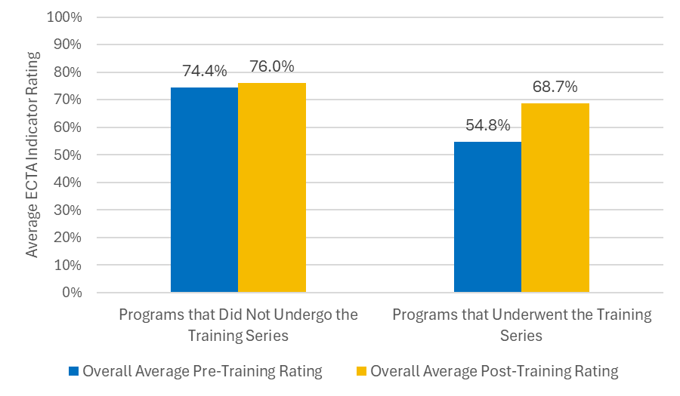
ICP Results
Likewise, the results of the ICP assessments demonstrated distinct differences between training and non-training groups:
- Training group (nine programs): Overall increase of more than 10 percentage points across the 12 ICP indicators. Adults’ Guidance of Children’s Free-Choice Activities saw the greatest growth between assessments, with strong growth also witnessed in Membership, Family-Professional Partnerships, Support for Communication, and Conflict Resolution. Only Adaptations of Space, Materials and Equipment experienced a slight decrease over time. Notably, this was the first topic discussed in sessions and training classrooms experienced high teacher turnover.
- Non-training group (12 programs): Slight overall change, averaging a decrease of less than ~1 percentage point. Less than half of the ICP indicators witnessed an increase between assessments, again underscoring the importance of professional development to sustain inclusive practices.

Chart 2: Overall Average ICP Indicator Score Increased for Programs that Participated in the Professional Development Sessions
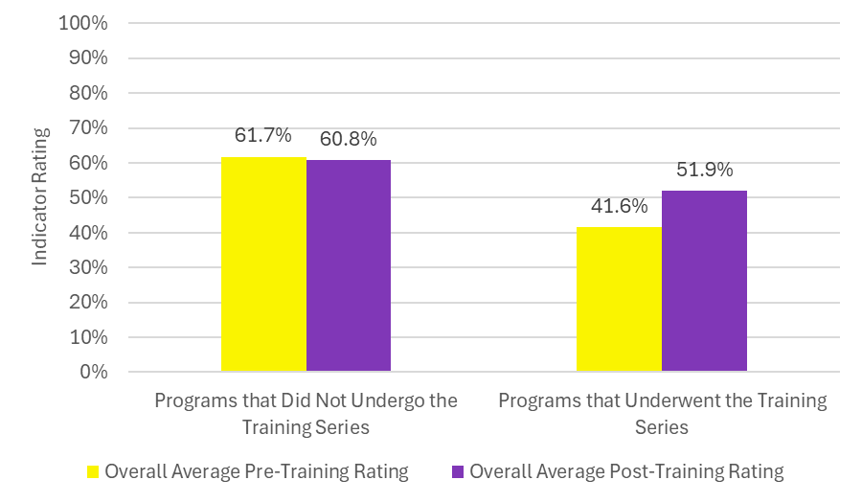

Significance and Effect Sizes of ECTA and ICP Results
The training had a statistically significant effect (α = 0.05) on the use and quality of the ECTA assessment tool, as well as the following ICP practices:
- Adults’ guidance during free-choice activities and play
- Conflict resolution
- Membership (sense of belonging)
While the impact of the training on other ECTA and ICP tools was found statistically insignificant, the training demonstrated medium to very large effect sizes on most of those tools. Overall, these results suggest that training improved not only instructional practices but also the quality of interactions that shape children’s day-to-day classroom experience.

To ensure consistency, effect sizes for both tools are reported together:
- Very small effects (<0.20):
  - ECTA Results: Promotion and Affirmation of Individual Differences
  - ICP Results: Adult Involvement in Peer Interactions, Relationships between Adults and Children, Family-Professional Developments, and Monitoring Children’s Learning
- Small effects (~0.20-0.39):
  - ECTA Results: Social-Emotional Learning and Development, and Instruction
  - ICP Results: Adaptations of Space, Materials and Equipment*
- Moderate effects (~0.40-0.79):
  - ECTA Results: Family Partnerships, Curriculum, Collaborative Teaming, and Culturally Responsive and Identity Affirming Practices
  - ICP Results: Support for Communication, and Feedback
- Large effects (~0.80-1.19):
  - ECTA Results: Meaningful Interactions with Peers, and Assessment of Children’s Learning and Development
  - ICP Results: Conflict Resolution, Adaptations of Group Activities, and Transitions between Activities
- Very large effects (>1.19):
  - ECTA Results: None
  - ICP Results: Adults' Guidance of Children's Free-Choice Activities and Play, and Membership

Table 3: The Supporting All Learners to Thrive Professional Development Pilot had Moderate to Large Impacts on the Majority of ECTA Indicator Scores

Early Childhood Technical Assistance (ECTA) Indicators | Effect Size of the Supporting All Learners to Thrive Professional Development Pilot
Promotion and Affirmation of Individual Differences | 0.10
Family Partnerships | 0.79
Social Emotional Learning and Development | 0.37
Meaningful Interactions with Peers | 0.81
Curriculum | 0.61
Instruction | 0.28
Collaborative Teaming | 0.45
Assessment of Children’s Learning and Development | 0.83
Culturally Responsive and Identity Affirming Practices | 0.74
Table 4: The Supporting All Learners to Thrive Professional Development Pilot had Moderate to Very Large Impacts on the Majority of ICP Indicator Scores

Inclusive Classroom Profile (ICP) Indicators | Effect Size of the Supporting All Learners to Thrive Professional Development Pilot
Adaptations of Space, Materials and Equipment | 0.32*
Adult Involvement in Peer Interactions | 0.14
Adults' Guidance of Children's Free-Choice Activities and Play | 1.24
Conflict Resolution | 0.96
Membership | 1.23
Relationships Between Adults and Children | 0.17
Support for Communication | 0.46
Adaptations of Group Activities | 0.93
Transitions Between Activities | 0.83
Feedback | 0.69
Family-Professional Partnerships | 0.06
Monitoring Children's Learning | 0.07

* The effect size of Adaptations of Space, Materials and Equipment reflects a negative, albeit small change in assessment scores.
Note: Effect sizes below .80 are considered moderate to strong, even when approaching the conventional “large” thresholds.

Child Retention and Exits
During the pilot, 29 child exits were documented across 21 classrooms. As shown in Chart 3, the most common reasons were family relocation (24%), children aging out of the program (14%), and transportation issues (10%). Smaller shares of exits were linked to scheduling conflicts (10%), financial hardship (7%), or perceptions that the program could not meet the family’s needs (3%). Importantly, most exits were not tied to behavioral or developmental needs – for example, families who required transportation or sought a religious program. These exits occurred across both training and non-training programs, with training programs representing 55.6% of all exits and non-training programs 44.4%. This distribution highlights that disenrollment reasons were diverse and not confined to program participation in training.

Chart 3: Families Left Child Care Programs for a Multitude of Reasons, few of which were Tied to Children’s Behavioral or Developmental Needs
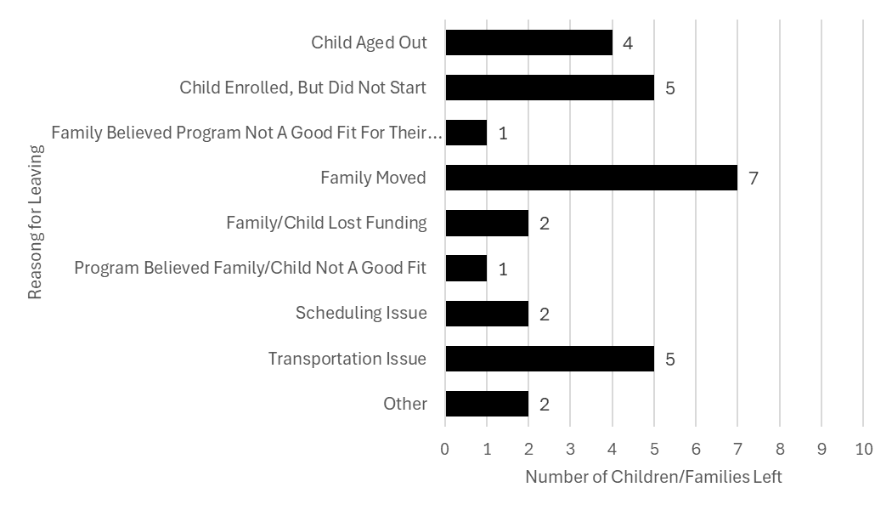
When asked whether they could meet the needs of children, most programs (14) reported confidence in doing so, while three acknowledged they could not. Two of these cases were unrelated to behavioral needs – one involved transportation and another a preference for a religious program – while the third reflected a program’s challenge in meeting a child’s needs despite training participation. This highlights that even programs receiving additional support may encounter limits without stronger system-level resources.
Programs also reported on their use of additional supports. Thirteen programs indicated they accessed external resources (e.g., referrals, consultation, or specialized services), while 12 reported no use of outside supports. Training participants were somewhat more likely to report accessing these supports compared to non-participants.
Findings further revealed encouraging evidence that programs avoided informal exclusionary practices during the pilot. No programs reported calling families for early pickups, and only two reported temporarily removing a child from the classroom, both in rare circumstances. This suggests that even when challenges arose, programs largely avoided practices that disrupt continuity of care and family stability.
Finally, child demographics showed that most children tracked were ages 3–5, with a relatively balanced gender distribution (10 female, 7 male).
Among children with available demographic information, Black (n=5) and Hispanic (n=4) children represented a notable share of those affected, underscoring the importance of monitoring racial disparities in access, retention, and support.
Interpretation
The findings show that professional development that is targeted, sustained, and explicitly aligned with trauma-informed and culturally responsive practices produces measurable improvements in classroom quality. Gains were strongest in domains emphasizing inclusive practices, family partnerships, and identity-affirming instruction, suggesting these focus areas resonate with educators and translate into tangible shifts in practice.
However, workforce instability remained a major barrier to sustaining progress. None of the participating programs retained their full teaching teams across both assessment periods. Seven classrooms did maintain the same lead teacher for both pre- and post-assessments, but each experienced turnover among assistant teachers. This turnover likely weakened improvements in interaction-dependent domains such as peer engagement, conflict resolution, and relationship-building. These results underscore the importance of coupling professional development with strategies that stabilize the workforce, ensuring training investments are not lost to attrition and that inclusive practices are sustained over time.

Promising Strategies from Other States, and Implications for Pennsylvania
Other states have pioneered approaches that Pennsylvania can learn from. Their experiences show that reducing exclusionary discipline requires more than isolated reforms; it depends on coordinated policies, transparent data systems, sustained workforce supports, and family-centered strategies.
State Policy and Data Monitoring
Several states have enacted statewide policies to reduce or prohibit preschool expulsion and suspension.
- Illinois passed the Early Childhood Expulsion Prevention Act (2017), which prohibits expulsions in publicly funded programs, requires providers to document steps taken before asking a child to leave, mandates referrals to support services, and strengthens family engagement (Illinois General Assembly, 2017).
- Connecticut was one of the first states to link expulsion-prevention policy with mandatory data collection, enabling the state to monitor disparities and evaluate the impact of interventions (Gilliam, 2005; Connecticut Office of Early Childhood, 2018).
These examples underscore the importance of pairing policy with data systems that track both formal and informal removals. Without systematic reporting, disparities remain hidden, and states cannot effectively target resources.

Leveraging CCDBG Quality Funds
Some states have strategically used Child Care and Development Block Grant (CCDBG) quality funds to expand preventive supports.
- Colorado invested CCDBG funds to strengthen its statewide Infant–Early Childhood Mental Health Consultation (IECMHC) system, embedding consultation into QRIS benchmarks (Colorado Office of Early Childhood, 2020).
- Michigan directed CCDBG quality dollars toward preventive coaching models, requiring programs to access consultation and coaching supports before considering exclusion (Michigan Department of Education, 2021).
These approaches ensure that quality improvement resources are directly tied to inclusion and prevention of exclusionary discipline.

Effectiveness of IECMHC
Research from multiple states demonstrates that IECMHC reduces preschool expulsion and improves teacher well-being.
- In Connecticut, the Early Childhood Consultation Partnership (ECCP) has been rigorously evaluated and linked to lower expulsion rates, stronger teacher-child relationships, and reduced teacher stress (Gilliam, 2007; Perry et al., 2010).
- Arkansas expanded IECMHC statewide, embedding consultants in both center-based and family child care settings, with evidence of improved classroom climate and reduced removals (Conners-Burrow et al., 2017).
The evidence base shows that consultation supports both child development and educator stability, making it one of the most effective levers for reform.
Restorative and Community-Based Approaches
States are also piloting restorative practices and family-inclusive planning models.
- California has integrated restorative practices in preschool and transitional kindergarten programs, emphasizing relationship repair and conflict resolution (California Department of Education, 2020).
- Oregon embedded family-inclusive behavior planning into community-based teams, ensuring parents, educators, and specialists collaborate on supports rather than defaulting to exclusion (Oregon Early Learning Division, 2019).
These models highlight how interdisciplinary, restorative approaches reduce suspensions while strengthening trust and partnership with families.

Policy Roadmap for Reducing Exclusionary Discipline in Pennsylvania

These findings highlight the need for immediate and long-term reforms. The following roadmap outlines short-term actions to meet urgent needs and long-term strategies to build sustainable change.

Short-Term Policy Recommendations (1–3 Years)
Priority Area | Key Actions | Why This Matters | Impact for Pennsylvania
Reduce and Address Exclusionary Discipline in ECE | Require programs to document all exclusionary discipline decisions with re-entry plans and family-inclusive planning. Collect and track statewide data on suspension and expulsion across CCW, Head Start, and PKC, with accountability mechanisms such as OCDEL reporting, ELRC support, and program-level audits. | Early suspensions/expulsions harm development and disproportionately affect Black boys and children with disabilities. Inclusive alternatives reduce reliance on exclusion. | Creates accountability, ensures exclusion is rare, transparent, and paired with support.
Expand Access and Funding and Funding for Family Support Services | Fund Rapid Response initiatives to ensure timely support for families and programs. Develop and expand a Family Navigator model (not currently state-funded) to guide families through child care subsidies, Early Intervention (EI), and community resources, paired with awareness strategies such as family-facing webinars, text campaigns, and partnerships with pediatricians and faith-based groups. | Family instability is a major driver of exclusion. Strengthening supports reduces stress, improves attendance, and stabilizes child participation. | Families gain faster access to critical supports, reducing disruptions in children’s learning.
Provide Add-On Payments for Programs Serving Children with IEPs/IFSPs | Establish additional payments to offset costs of serving children with disabilities. | Programs often exclude children with higher needs because of resource constraints | Promotes inclusion, reduces exclusions, and ensures equitable access for children with disabilities.
Expand Infant–Early Childhood Mental Health Consultation (IECMHC) | Use CCDBG quality funds and state dollars to expand regional IECMHC capacity and increase provider awareness. Require consultation prior to exclusion | IECMHC is proven to reduce expulsions, lower teacher stress, and strengthen child–teacher relationships. | Ensure every program can access rapid-response consultation before exclusion decisions.
Incentivize Professional Development for Educators | Provide incentives for professional development in trauma-informed care, family engagement, EI navigation, and communication, using core content from the Supporting All Young Learners to Thrive training (developed from ICP indicators). Link training to Keystone STARS credentials and offer tiered options – online, hybrid, and on-site – paired with job-embedded coaching. ELRC Quality Coaches can support high-turnover programs through on-site coaching, staff mentoring, and integration of training into daily practice. | One-off training does not change practice. Incentivized, sustained PD improves capacity for inclusive care. | Builds a skilled, equity-driven workforce prepared to prevent exclusion.
Develop Parent Resource Guides on Rights and Supports | Develop standardized, multilingual family documents that combine “know your rights” guidance with proactive resource information to ensure families are informed before conflicts arise. | Families often face exclusion without knowing their rights or appeal options. | Empowers parents to advocate for their children and demand fair treatment.
Strengthen Parent Intake Processes | Require programs to hold intake meetings with families to review policies, discipline procedures, and a Family Rights and Resources guide. Modeled after the Head Start intake process. | Clear expectations build trust and prevent misunderstandings that lead to exclusion. | Stronger partnerships between families and providers; greater transparency.
Streamline Early Intervention Referrals | Reinforce existing IDEA benchmarks (timely evaluations, IFSP-to-IEP transitions) by strengthening compliance monitoring already in place. Expand bilingual staff and translated materials to meet language access obligations. | Long delays (six – 12 months) in EI access fuel exclusion. Early supports are critical for success. | Children receive services faster, reducing risk of exclusion and developmental harm.

Long-Term Policy Recommendations (3–5 Years)
Priority Area | Key Actions | Why This Matters | Impact for Pennsylvania
Compensation, Recruitment, and Retention (System-Wide Challenge) | Establish competitive compensation and pay parity across ECE and K–12 settings; offer retention bonuses, benefits, and targeted recruitment supports; expand career pathways with reflective supervision and wellness supports; and increase EI provider reimbursement rates to stabilize the workforce. | Workforce instability drives exclusion when programs lack staff or cannot retain qualified educators. Low pay is a leading cause of turnover. | Stabilized workforce, stronger capacity for inclusion, and equitable access to qualified educators across the state.
Mandate Data Tracking of Suspension and Expulsion | Require standardized data reporting across all child care and preschool settings, including informal removals, with data disaggregated by race, disability, age, and program type. Pair this mandate with dedicated funding to ensure feasibility. Data should be used not only to track disparities after they occur but also to inform targeted responses – such as training, technical assistance, or resource allocation – when concerning trends emerge. | Without consistent statewide data, exclusion remains invisible. A proactive system allows early identification and correction of inequities. | Build a comprehensive monitoring system that drives equity and accountability.
Mandate Training on Core Competencies | Require all ECE educators to complete training in trauma-informed practice, family engagement, EI navigation, and effective family communication. Core training content should be standardized across the state, informed by data from ICP and aligned with evidence-based resources such as those developed by NCPMI. | Embedding competencies ensures consistency across the workforce. | Creates a highly skilled, equity-centered workforce.
Standardize Higher Education Preservice Requirements  Standardize Higher Education Preservice Requirements (continued) | Align ECE degree and certification programs statewide to include core competencies.  (Note: This is a long-term pipeline goal, aligned with certification changes already underway in Pennsylvania.) | Current preservice training is inconsistent, leaving new educators underprepared. | Strengthens the educator pipeline, improves instructional quality, and elevates the profession.
Create a Centralized Entity for Coordinated Services | Develop a “one-stop hub” to connect EI, IECMHC, behavioral health, and community supports with shared data systems. | Families now face fragmented, inequitable referral pathways. | Reduces delays and improves outcomes with a seamless family navigation system.
Strengthen Accountability and Continuous Improvement | Use removal and inclusion data to drive improvement plans, not punishment. Fund research partnerships to test restorative practices, peer advocacy, and integrated consultation. | Current compliance systems focus on penalties rather than solutions. Continuous improvement builds a learning system. | Shifts PA toward a supportive accountability culture that reduces inequities and scales effective practices.

Together, these short- and long-term actions form a comprehensive roadmap for reducing exclusionary discipline across Pennsylvania’s early childhood system. By aligning policy, practice, and resources, the state can move toward an equitable future where all young children have the opportunity to learn, grow, and thrive.

Discussions & Implications
While the policy roadmap provides clear strategies for action, it is equally important to understand the systemic barriers that make exclusionary discipline so persistent. Findings highlight how inequities in data, access, workforce stability, and referral systems contribute to the overuse of exclusionary practices. These challenges reinforce the urgent need for a statewide approach to reduce and address exclusionary discipline in ECE – allowing only narrowly defined safety exceptions – paired with inclusive supports and due-process protections. The following discussion explores these challenges and their implications for children, families, providers, and policymakers.

System Challenges
- Lack of Statewide Exclusion Data
Pennsylvania currently lacks a mandatory, statewide system to track exclusionary discipline across all ECE settings. While public schools collect some data, child care centers, family child care homes, and private preschool programs are not held to the same reporting requirements. Informal removals – such as early pickups, shortened schedules, or discouragement from re-enrollment – are rarely documented. Without standardized data, policymakers cannot monitor equity, identify trends, or hold programs accountable, leaving the true scale of exclusion largely invisible.

- Access Bottlenecks to Supports
Providers consistently reported long delays in accessing Infant–Early Childhood Mental Health Consultation (IECMHC), Early Intervention (EI), and behavioral health services. From their perspective, wait times often stretched for months, leaving programs with few immediate options and contributing to exclusionary decisions. It remains unclear, however, whether these delays reflect true service waitlists or the reality that referral and intake processes are not designed as rapid-response systems. These challenges were described as most acute in under-resourced communities and for multilingual families, where pathways were slower and harder to navigate.

- Workforce Fragility
The ECE workforce remains fragile, marked by low wages, limited benefits, staff shortages and high turnover. Educators often receive only minimal professional development each year – insufficient for sustained change in practice. High turnover further erodes continuity, meaning investments in training are often lost when staff leave. This instability undermines program capacity to deliver consistent, high-quality, inclusive care.

- Complex and Inequitable Referral Systems
Families described referral systems for EI and behavioral health as confusing, fragmented, and inequitable. Navigating these systems requires persistence and resources that many families – especially hourly workers, single-parent households, or families managing multiple stressors – struggle to provide. Multilingual and non-English-speaking families faced additional barriers when interpretation services and culturally competent supports were limited. These inequities compound disparities and contribute to uneven access to needed supports.

- Bias and Policy Inconsistency
Disproportionality in exclusionary discipline reflects both implicit bias and inconsistent program policies. Families of Black and Hispanic boys reported higher rates of behavioral contacts and program discouragement, even when behaviors were no different from peers. Providers acknowledged the need for anti-bias and culturally responsive training, yet without clear statewide policy requirements, programs apply inconsistent standards. Some invest in inclusion, while others resort more quickly to exclusion – creating inequitable experiences for children depending on where they are enrolled.

- Documentation Gaps and Lack of Due Process
Many exclusions occur without written documentation. Families are left with no clear pathway to appeal or advocate for their child, while policymakers lack actionable data to guide reforms or allocate resources effectively. Families described this as the “invisible visible” problem: exclusions were highly disruptive in daily life yet invisible in official records. Unless documentation requirements and due-process protections are strengthened, exclusionary practices will continue unchecked, eroding accountability and equity.

Implementation Considerations and Implications for Pennsylvania
Pennsylvania has an opportunity to build on the lessons emerging from other states by developing a comprehensive, statewide framework for discipline reform in early childhood programs. Key strategies include:
- Establishing a statewide IECMHC network modeled after Connecticut’s Early Childhood Consultation Partnership (ECCP) and Colorado’s consultation systems, ensuring consultation is accessible across all program types.
- Embedding consultation requirements prior to exclusion, following Illinois’ Early Childhood Expulsion Prevention Act, which mandates documented supports and referrals before any child is asked to leave.
- Aligning professional development and coaching with Keystone STARS and preservice pathways, as Michigan has done by integrating consultation and coaching into QRIS quality standards.
- Exploring restorative and family-inclusive approaches that reflect Pennsylvania’s diverse communities, drawing on models from California and Oregon that emphasize relationship repair and shared decision-making with families.
By drawing on these proven strategies, Pennsylvania can ensure that discipline reform is not only policy-driven but also practically supported, equitable, and sustainable.

Conclusion
Reducing and addressing exclusionary discipline in ECE requires more than incremental change; it requires a decisive shift in policy and practice. Pennsylvania must adopt a comprehensive strategy to reduce and address suspensions and expulsions in early childhood education programs – permitting only narrowly defined safety exceptions – while simultaneously investing in workforce stability, family supports, and proven strategies like Infant–Early Childhood Mental Health Consultation. By committing to this framework, Pennsylvania can transform exclusionary discipline from a hidden barrier into an opportunity for equity, inclusion, and lasting educational success.
To succeed, Pennsylvania must:
- Center Equity by disaggregating exclusion data, co-designing solutions with families and providers, and addressing practices that disproportionately harm Black children, Hispanic boys, and children with disabilities.
- Stabilize the Workforce through fair pay, benefits, retention supports, and job-embedded coaching to ensure that inclusive practices are sustainable.
- Ensure Documentation and Due Process by ensuring families consistently receive written notices, transition (re-entry) plans for children returning to child care programs, and transparency around decision-making.
- Invest in Proven Strategies such as Infant–Early Childhood Mental Health Consultation (IECMHC), sustained coaching, and family partnership models that are already demonstrating success.
- Measure Progress Consistently by tracking reductions in exclusions, improvements in practice, and increases in family stability and satisfaction.
Policy change is only the first step. Without intentional follow-through, workforce supports, and continuous monitoring, reforms risk being symbolic rather than transformational. But with commitment to equity, transparency, and investment in strategies that work, Pennsylvania can move beyond compliance to create an early learning system where every child has the opportunity to thrive.
Now is the time to act decisively – transforming exclusionary discipline from a hidden barrier into a catalyst for equity, inclusion, and lasting educational success.

Appendixes
Appendix A – Survey Data: Demographics of Child Care Provider Survey Participants
Chart 1A: Child Care Provider Survey Participants by Region
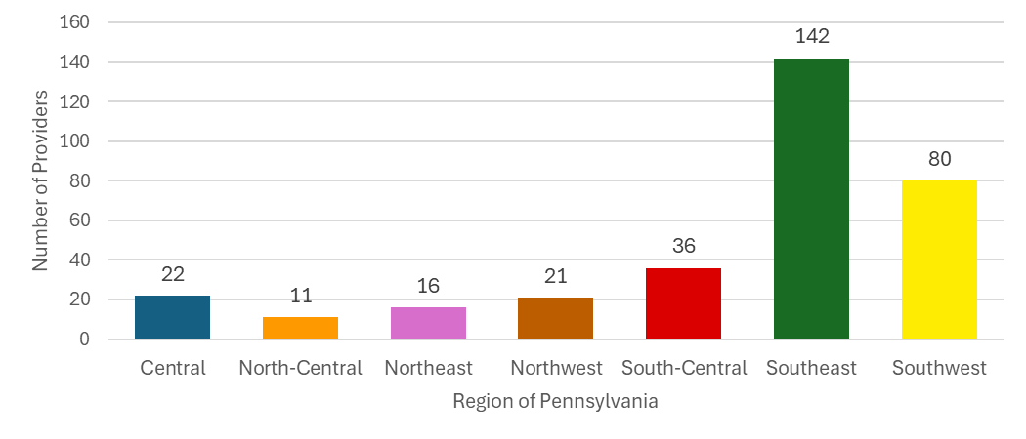

Chart 2A: Child Care Provider Survey Participants by Program STAR Quality Rating
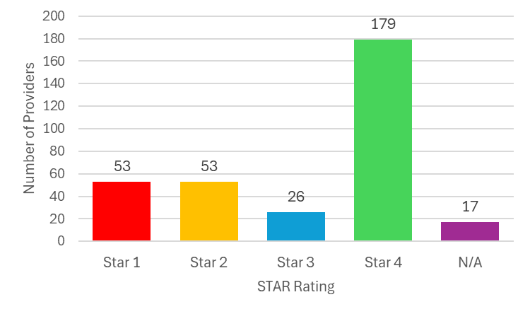
Chart 3A: Child Care Provider Survey Participants by Type of Child Care Program Operated
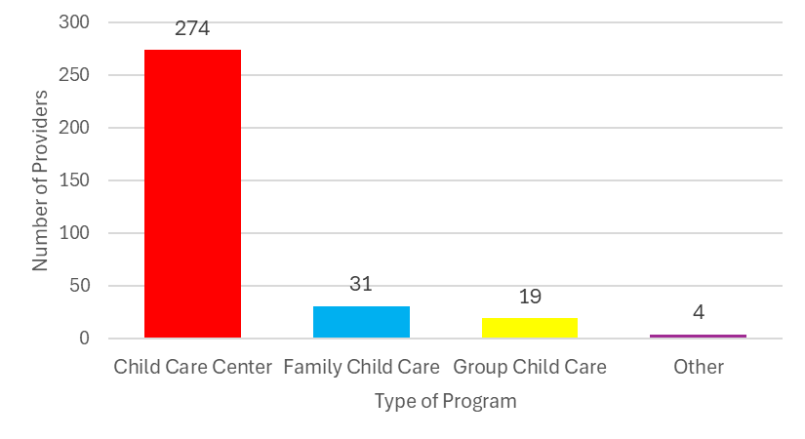

Chart 4A: Child Care Provider Survey Participants by Funding Source of Child Care Program

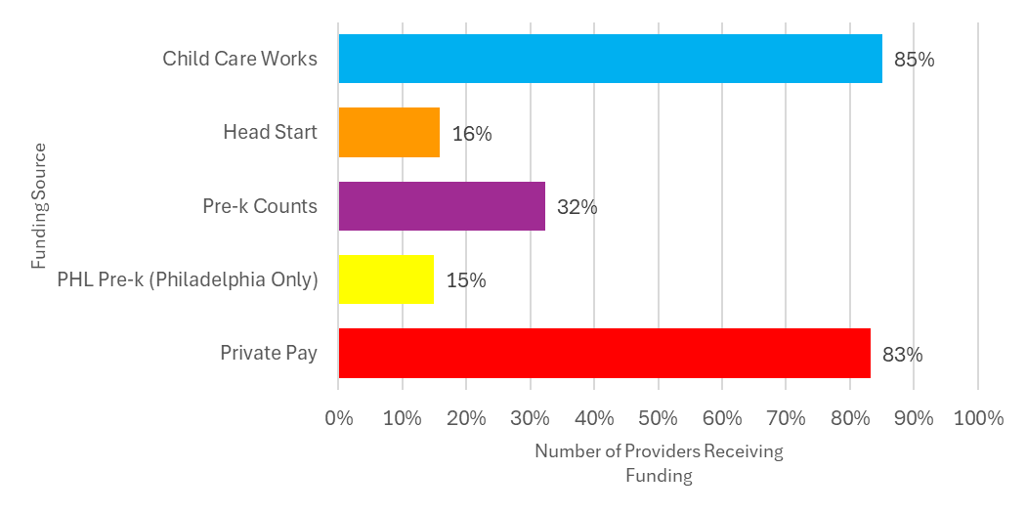
Appendix A – Survey Data: Provider Survey Questions
Chart 5A: Expulsion and Suspension Prevention and Behavioral Health Resources Used by Child Care Provider Survey Participants
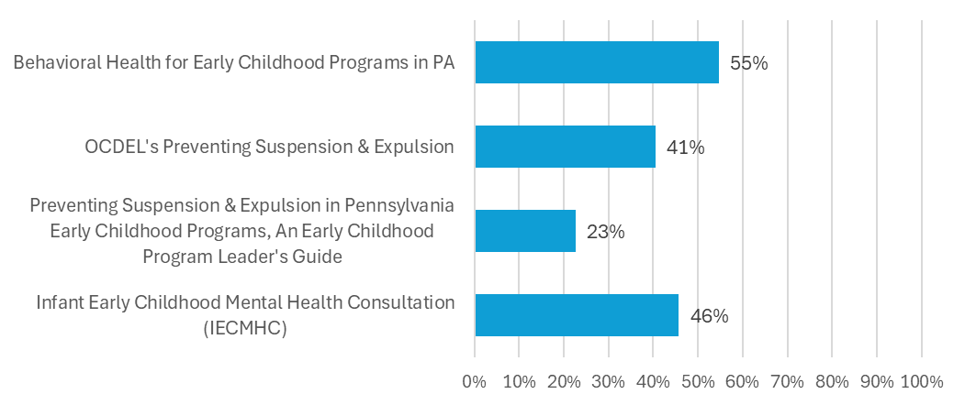

Chart 6A: Child Care Provider Survey Participants Tracking Data on Challenging Child Behaviors and Subsequent Classroom and Program Responses
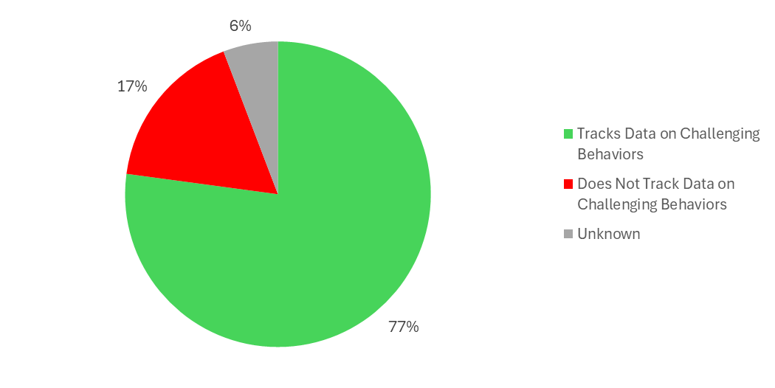

Chart 7A: Child Care Provider Survey Participants with Teachers, Owners and/or Directors who Partner Effectively with Families to Support Each Child’s Success in the Classroom
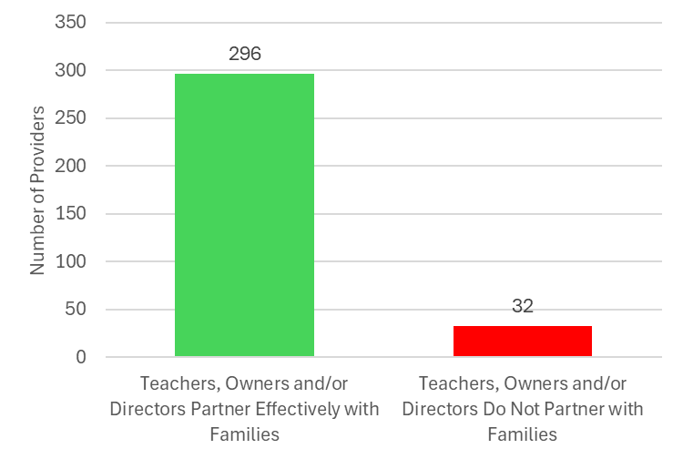
Chart 8A: Child Care Provider Survey Participants with Teachers who Receive Training on Strategies to Reduce Children’s Challenging Behaviors
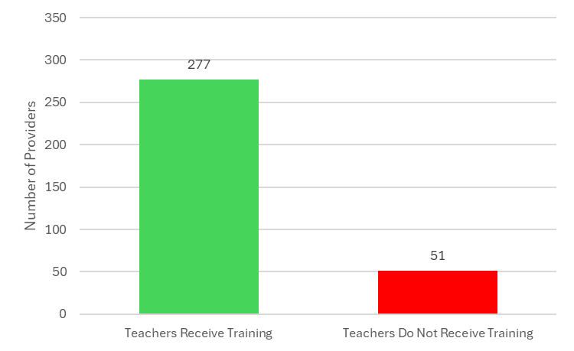
Chart 9A: Child Care Provider Survey Participants with Teachers who Receive Training on Implicit Bias and Cultural Awareness
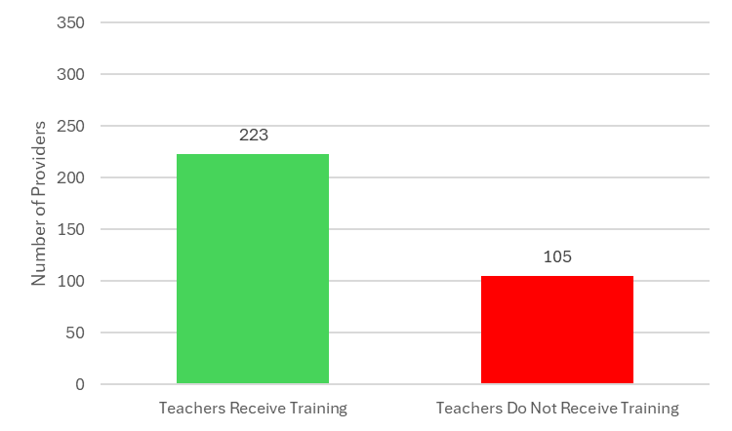

Appendix A – Survey Data: Demographics of Parent Guardian Survey Participants
Chart 10A: Parent Guardian Survey Participants by Region of Residence
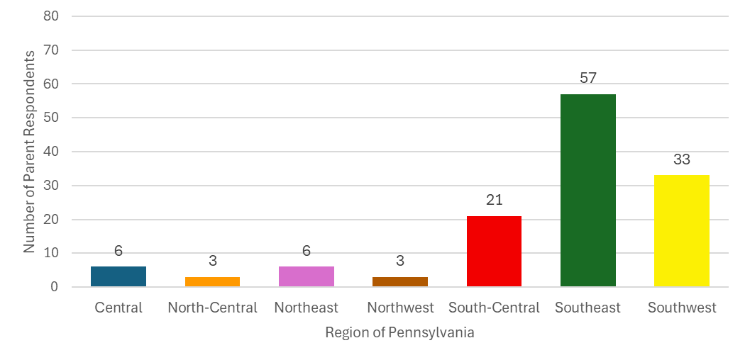

Chart 11A: Parent Guardian Survey Participants by Race/Ethnicity of the Child
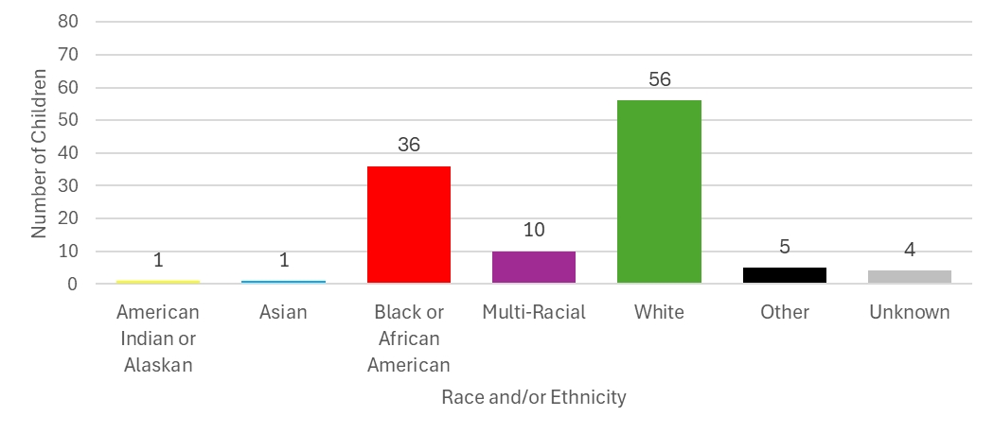

Chart 12A: Parent Guardian Survey Participants by STAR Quality Rating of the Child Care Program their Child Attends
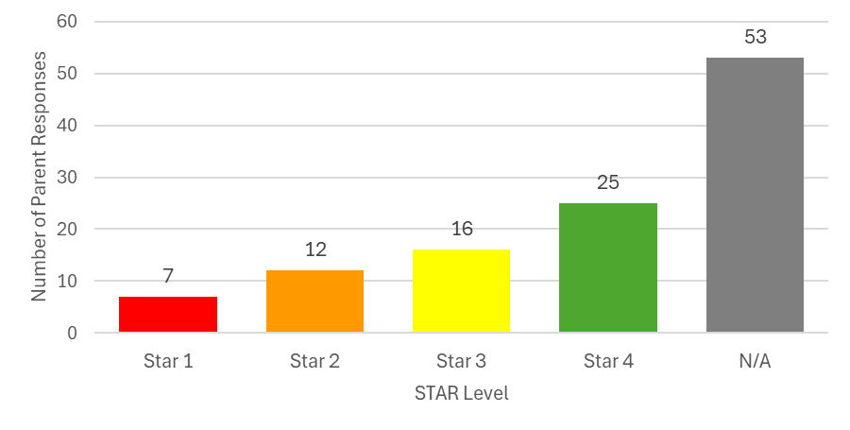

Chart 13A: Parent Guardian Survey Participants by Type of Child Care Program their Child Attends
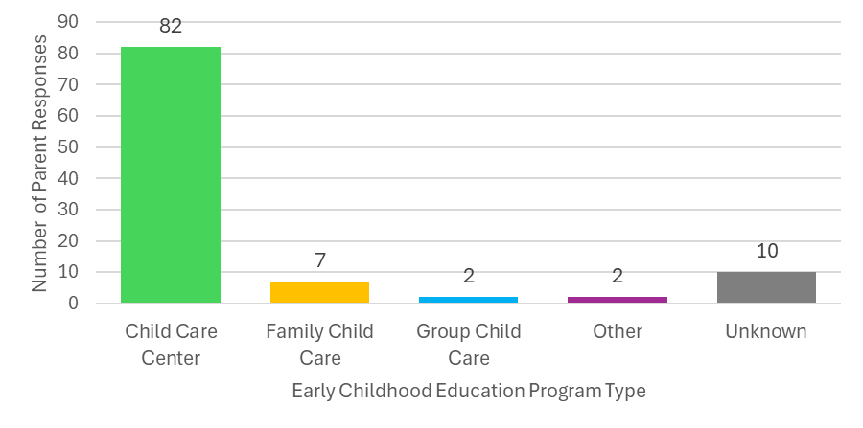

Chart 14A: Parent Guardian Survey Participants by Child Care and Pre-K Funding Source
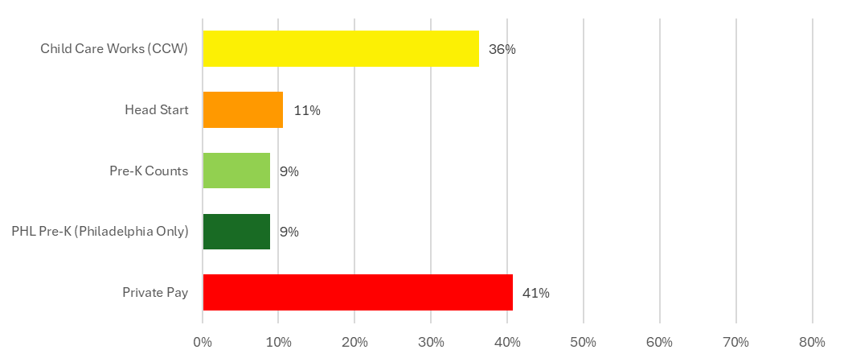

Appendix A – Survey Data: Parent Guardian Survey Questions
Chart 15A: Parent Guardian Survey Participants whose Children Stayed Enrolled for the Entire Child Care Program Year
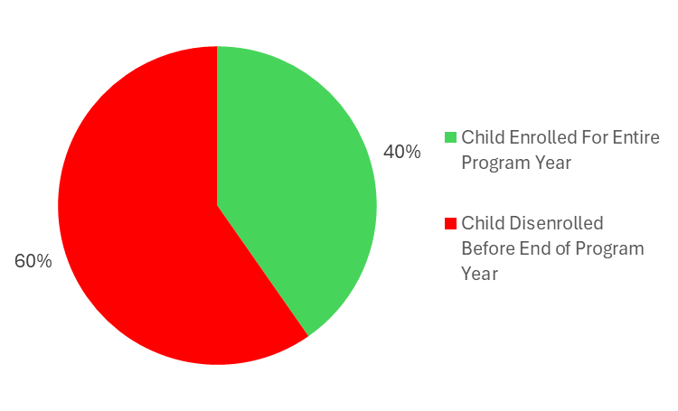

Chart 16A: Parent Guardian Survey Participants Called by their Child Care or Pre-K Program due to their Child’s Behavior
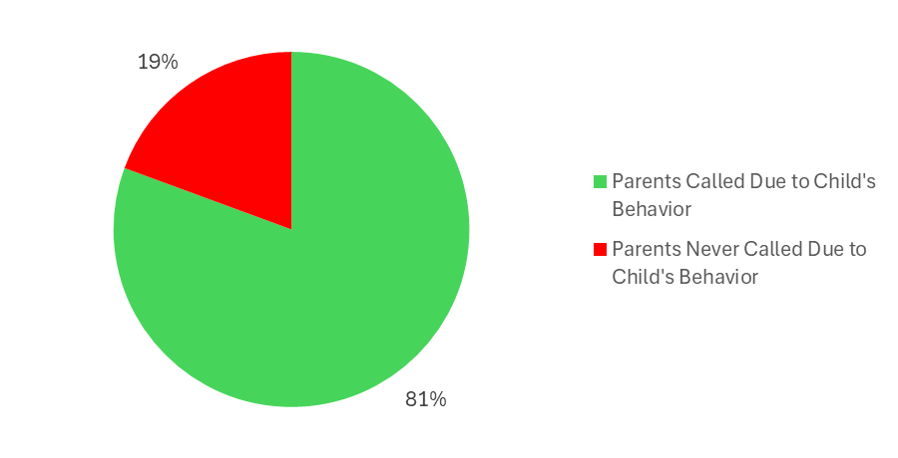
Chart 17A: Parent Guardian Survey Participants whose Child Care or Pre-K Program Created a Plan of Action to Respond to their Child’s Challenging Behaviors
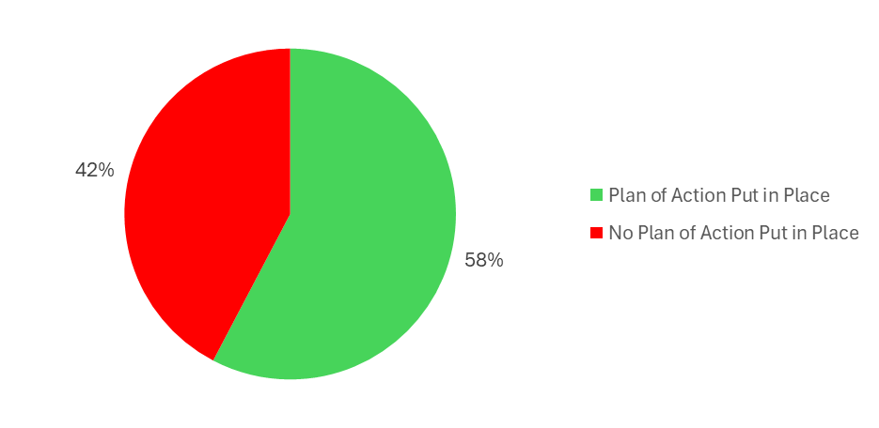

Chart 18A: Parent Guardian Survey Participants whose Child was Asked to Take Time Off from their Program at Least Once by their Teacher or Center Director due to their Child’s Challenging Behavior
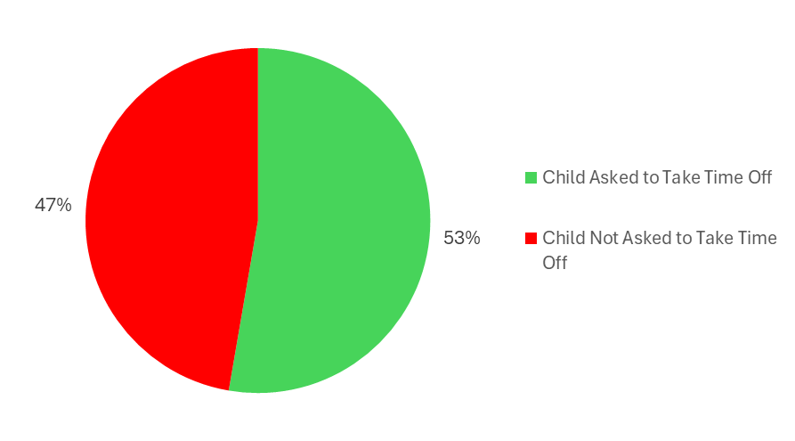

Chart 19A: Parent Guardian Survey Participants Asked to Remove their Child from a Child Care Program or Pre-K while Trying to Get Help and Support for their Child
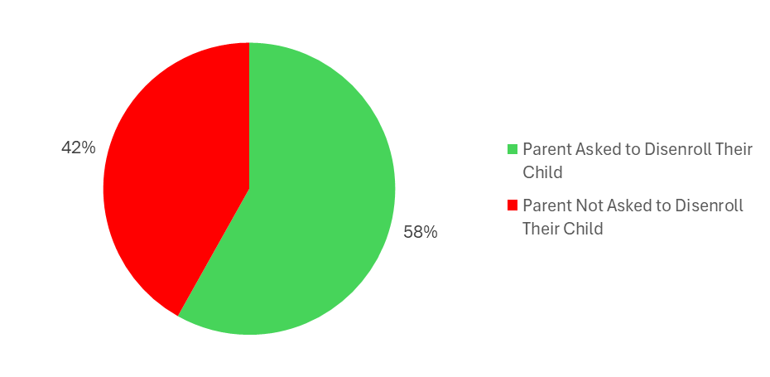

Chart 20A: Parent Guardian Survey Participants whose Child’s Program Assisted with their Child’s Enrollment Elsewhere after Being Asked to Disenroll
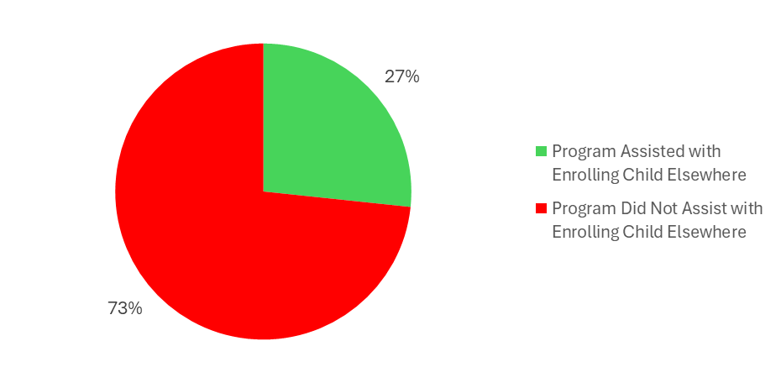

Appendix B – Focus Group/Interview Questions
Suspension/Expulsion Project - Focus Group Questions - Providers
Focus Group Questions
- How would you define suspension and expulsion?
- Do you have a policy regarding suspension and expulsion?
- If you have a suspension or expulsion policy, how do you share that information? With your parents? With your staff?
- Does your staff receive training on your policy? If so, please share?
- Are any children in the process of being referred for services?
- What is your process when you have identified children that may need additional resources?
- When do you notify parents when a child in your program may need additional services/resources?
- Over the past 12 months, how many children have been suspended or expelled from your program?
  - Does your program track if your children are removed from the classroom or being sent home? If so, how?
- Once a child receives services, do you have the opportunity to partner with the service coordinator/LEA/agency to ensure the child gets the support they need? (please share your experience)
- In case you feel you need to suspend or expel a child from your program, what data do you use? (ex: observations notes, behavioral logs)
- If a student exhibits challenging behavior in the classroom, what resources are available to staff?
- Does your staff know when to reach out for assistance when dealing with a child facing challenging behavior?
- What supports are needed to assist you (staff) with children who are exhibiting challenging behavior? (ex: PD, Coaching, Mental health supports, Behavioral Responses)
- Are you aware of any resources that OCDEL has put forth regarding suspension and expulsion?
- Is there anything you can recommend to prevent suspension and expulsion in your program? in ECE?

Appendix B – Focus Group/Interview Questions
Suspension/Expulsion Project - Focus Group Questions - Parents

Pre-Focus Group Questions/Pre-Screening Questions
- At what age did you enroll your child in child care or a pre-k program?
- What kind of child care or pre-k program did your child participate in, i.e., Head Start, Early Head Start, PHLpreK, Pre-K Counts?
- Before enrolling your child in child care or a pre-k program, what words would you use to describe their day-to-day behavior?
- How have educators described the behaviors of your child? Did this align with what you experienced at home or in a family member's care?
- Did you have the opportunity to meet with your child's teacher or child care center director to discuss your child's needs? If so, did the school provide you with any resources?
- Has the child care or pre-k program ever called you due to your child's "challenging behaviors?" If so, how many calls have you received within a year? Do you recall the age of your child when you began receiving these calls?
- If you have been called about your child's "challenging behaviors," was there a plan of action put in place for your child?
- If your child has an IEP or IFSP, has your child care provider initiated a meeting to discuss the different objectives of the IEP or IFSP? Or does your child’s teacher attend the IEP/IFSP meetings?
- Was your child asked to take time off the program at least once by their teacher or the center director due to behavior?
- Once enrolled, did your child stay enrolled for the entire program year? If not, please describe why your child had to transition.
- Have you been asked to disenroll from a child care program while trying to get help and support for your child? Did the program assist you with enrolling your child elsewhere?
- Did the family handbook of the child care or pre-k program identify a suspension and expulsion policy?
- Before being asked to leave the program, did the program director advise you of any policies regarding your child being potentially removed from the program?
- Is there anything additional you wish to share?

Focus Group Questions
- Do you recall the average number of children in your child's child care or pre-k program classroom?
- Do you recall your child's teacher being alone, or did they have an additional aide in the child care/classroom environment?
- What were the demographics, i.e., race, gender, etc., of your child's educator(s)?
- Do you believe your child had the full support to thrive in a child care/classroom environment? Why or why not?
- Have you been told your child care program is not a good fit for your child or cannot meet your child’s needs?
- Were you advised, or did you want to get your child evaluated? If yes, were you able to get your child evaluated? If not, what prevented you from getting your child evaluated?
- What services were you referred to for evaluation or support? (Early Intervention, Behavioral Health, Early Childhood Mental Health Consultation, etc.)
- Is your child in the process of being referred to services or additional support? What challenges or roadblocks did you run into when trying to get the services your child needs?
- If you are comfortable sharing, does your child have an IEP or IFSP?
- Are you aware of the resources available to support children in preventing behavioral problems or developmental delays, i.e., Community Behavioral Health, Elwyn, Pediatrician, or Philadelphia Family Voices?

Appendix C – Learning to Thrive Professional Development Pilot – Classroom Assessment Data: Early Childhood Technical Assistance (ECTA) Assessment Scores

Chart 1B: Average Early Childhood Technical Assistance (ECTA) Assessment Scores between Programs that Did and Did Not Participate in the Professional Development Pilot
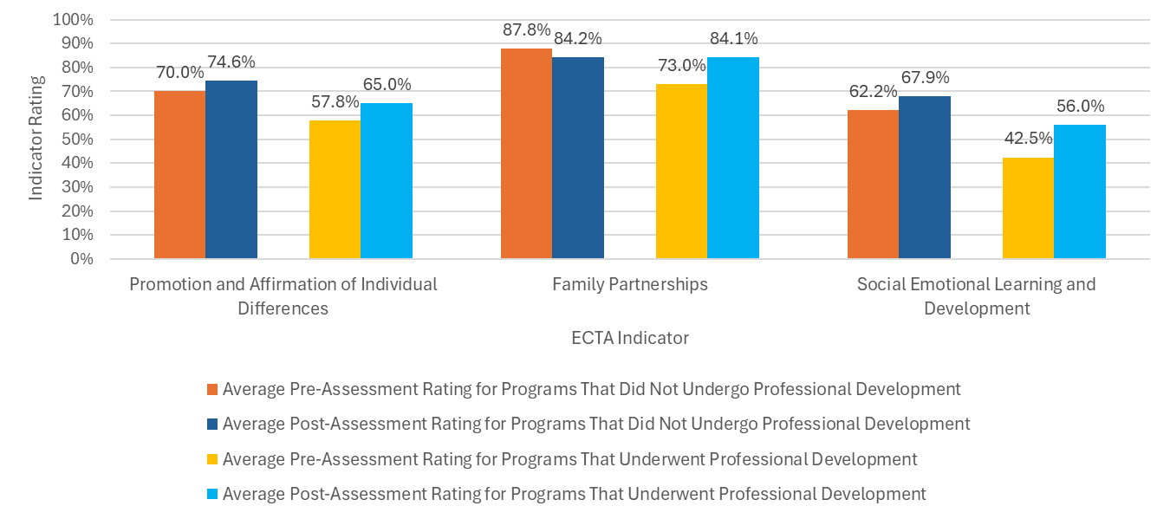

Chart 2B: Average Early Childhood Technical Assistance (ECTA) Assessment Scores between Programs that Did and Did Not Participate in the Professional Development Pilot
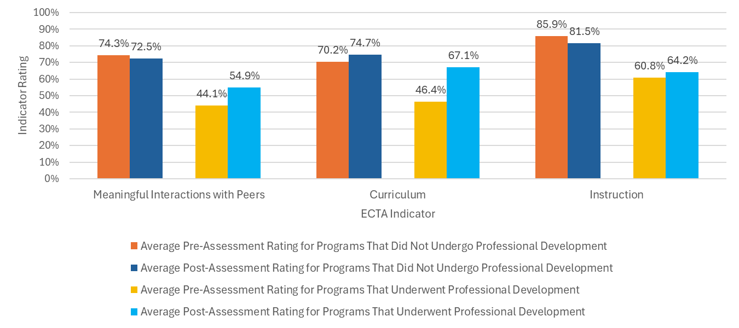
Chart 3B: Average Early Childhood Technical Assistance (ECTA) Assessment Scores between Programs that Did and Did Not Participate in the Professional Development Pilot

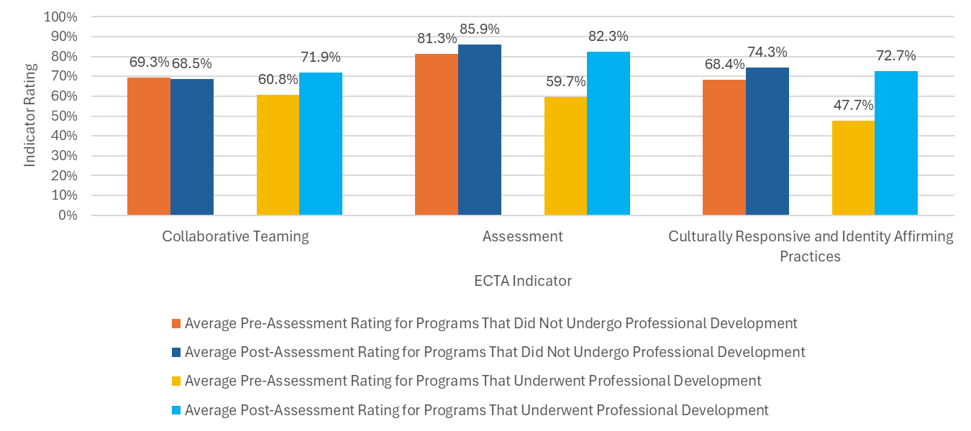

Appendix C – Learning to Thrive Professional Development Pilot – Classroom Assessment Data: Inclusive Classroom Profile (ICP) Assessment Scores

Chart 4B: Average Inclusive Classroom Profile (ICP) Assessment Scores between Programs that Did and Did Not Participate in the Professional Development Pilot
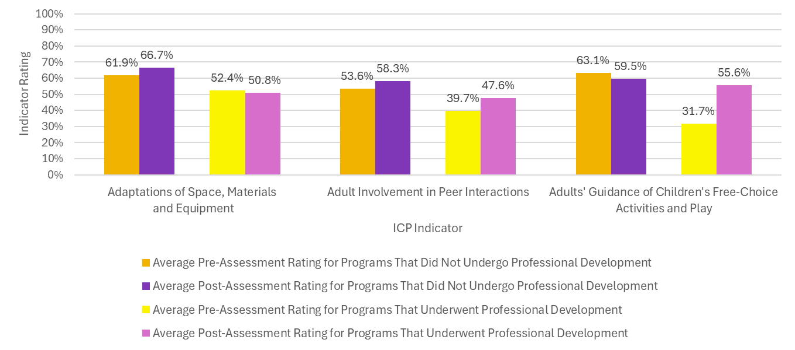
Chart 5B: Average Inclusive Classroom Profile (ICP) Assessment Scores between Programs that Did and Did Not Participate in the Professional Development Pilot
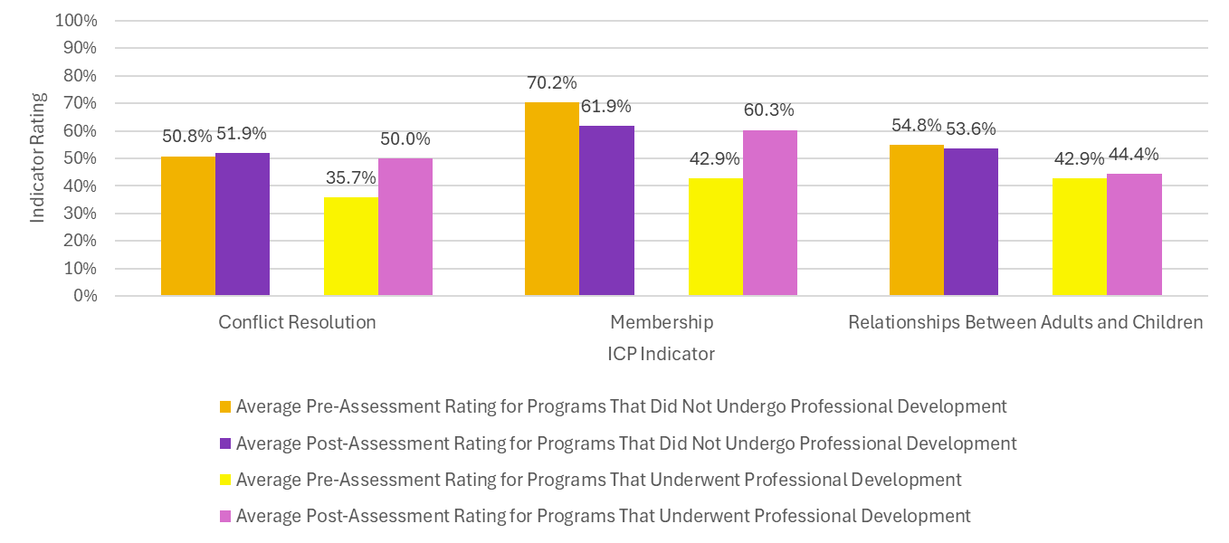

Chart 6B: Average Inclusive Classroom Profile (ICP) Assessment Scores between Programs that Did and Did Not Participate in the Professional Development Pilot
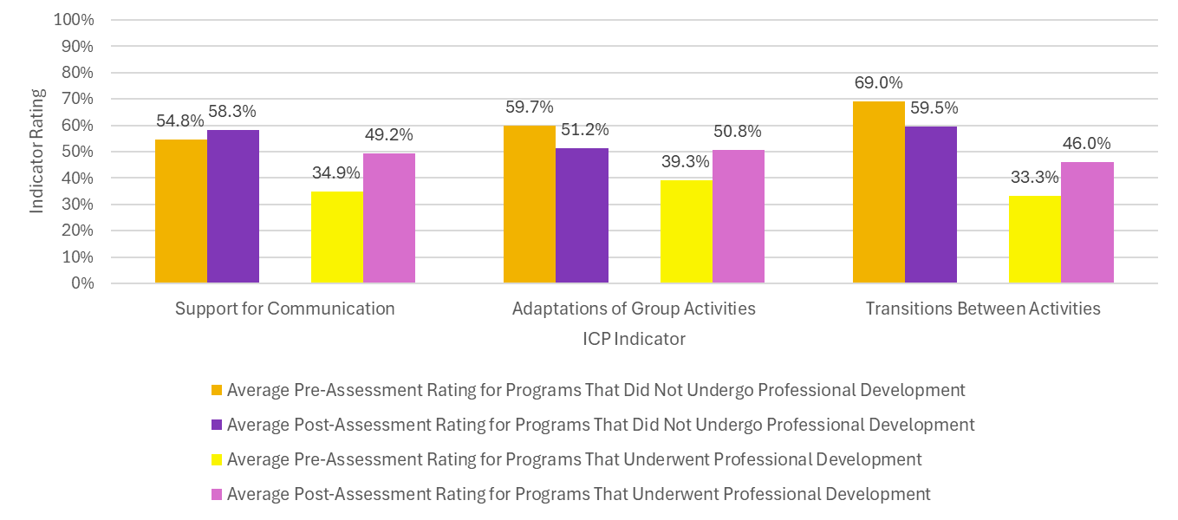

Chart 7B: Average Inclusive Classroom Profile (ICP) Assessment Scores between Programs that Did and Did Not Participate in the Professional Development Pilot
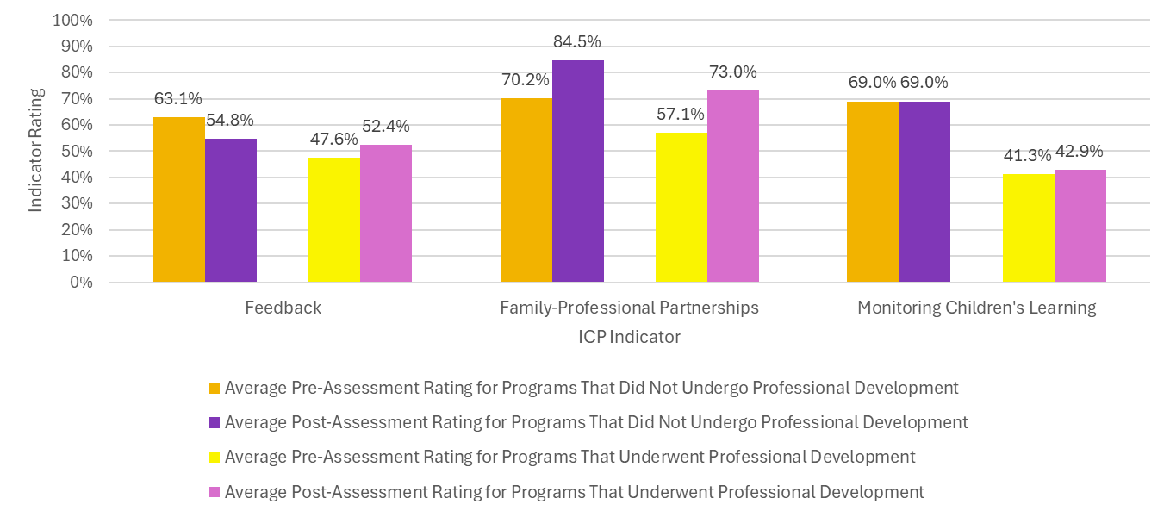

Appendix C – Learning to Thrive Professional Development Pilot – Classroom Assessment Data: Child Care Program Disenrollments during Professional Development Pilot

Chart 8B: Reasons Families Left Child Care and Pre-k Programs by Programs that Did and Did Not Participate in the Professional Development Pilot
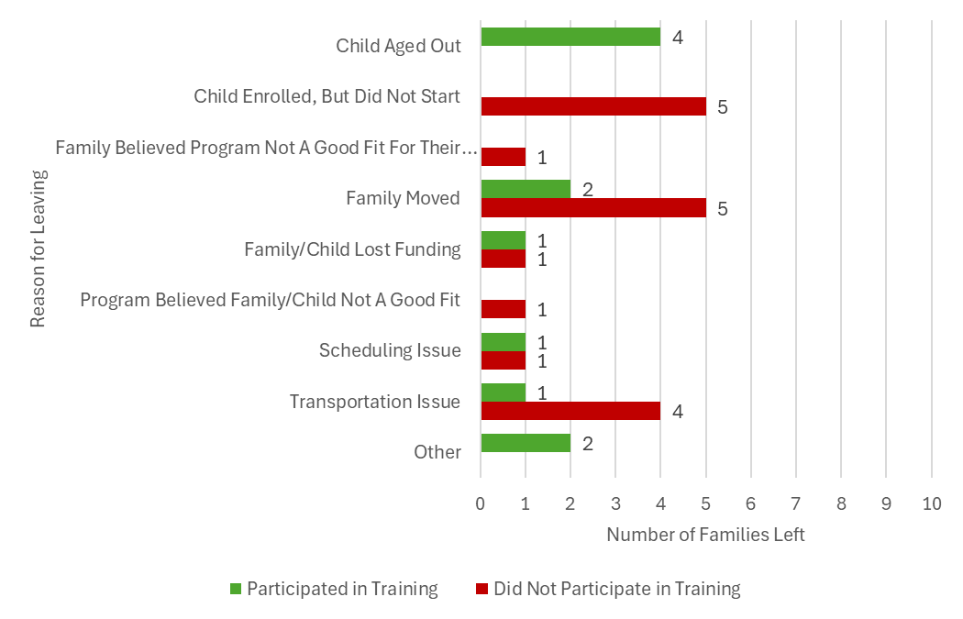
Appendix C – Learning to Thrive Professional Development Pilot – Classroom Assessment Data: Demographics of Children Who Left the Child Care Programs

Table 1B: Gender of Children Who Left the Child Care Programs
 | Male | Female | Unknown
Gender of Children | 10 | 7 | 12

Table 2B: Age Range of Children Who Left the Child Care Programs

 | Under 3 Years Old | 3-5 Years Old | Unknown
Age of Children | 0 | 17 | 12

Table 3B: Race/ Ethnicity of Children Who Left the Child Care Programs
 | American Indian or Alaskan Native | Asian or Asian American | Black or African American | Hispanic or Hispanic | Other | Unknown
Race/ Ethnicity | 1 | 2 | 5 | 4 | 4 | 13
Table 4B: Providers’ Treatment and Support of Children Who Left the Child Care Programs
 | Yes | No | Not Available
Did providers ever call a family member of the disenrolled child to pick up their child early due to behavioral issues? | 0 | 17 | 12
Did providers ever remove disenrolled child from their classroom due to behavioral issues? | 2 | 15 | 12
Did providers use resources to help support the disenrolled child and their family before they left? | 4 | 13 | 12
Did providers have the ability to meet the needs of the disenrolled child and their family? | 14 | 3 | 12
Appendix D - Glossary of Key Terms and Acronyms

CCDBG – Child Care and Development Block Grant: A federal funding stream that provides subsidies to help low-income families access child care and supports states in improving the quality of early learning programs.

Child Care Works (CCW): Pennsylvania’s child care subsidy program that helps low-income families afford child care while parents work or attend school.

Culturally Responsive Practice: Teaching and caregiving approaches that honor children’s cultural identities, languages, and experiences, while actively addressing bias and inequity.

Disenrollment: In this report, disenrollment refers to situations where families are asked – or feel pressured – to remove their child from an early childhood education (ECE) program, either temporarily or permanently, due to challenging behaviors or unmet needs. Disenrollment may be voluntary in form but is often experienced by families as exclusionary, particularly when it occurs without a clear plan, referral, or support for transition.

ECE – Early Childhood Education: Educational and care programs serving children from birth to age five, including child care centers, preschools, Head Start, and family child care homes.

ECMH / IECMHC – Infant–Early Childhood Mental Health Consultation: A prevention-based service in which mental health professionals partner with early childhood educators to address challenging behaviors, reduce expulsions, and support children’s social-emotional development.

ECTA – Early Childhood Technical Assistance Center (Environment Indicators): A framework and assessment tool used to evaluate system-level practices in early care and education, focusing on access, participation, and supports for children with disabilities.

EI – Early Intervention: Services and supports provided to young children with developmental delays or disabilities. In Pennsylvania, this includes Infant/Toddler EI (birth to three years old) and Preschool EI (ages three to five years).

Expulsion (in ECE): Permanent removal of a child from a program due to behavioral or developmental challenges.
Exclusion Data: Standardized information on suspensions, expulsions, and informal removals (sometimes called 'soft suspensions') in early childhood programs. Exclusion data include both formal removals and undocumented practices such as shortened days, early pickups, or requiring families to provide one-on-one support.
Family Navigator: A professional or program role that helps families understand and access child care, Early Intervention, health, and community services – often focused on reducing barriers for families in crisis or transition.
Head Start (HS): A federally funded early learning program promoting school readiness for young children from low-income families, including comprehensive services for health, nutrition, and family well-being.
ICP – Inclusive Classroom Profile: An observational tool that measures the quality of inclusive practices in early childhood classrooms across 12 indicators (e.g., participation, peer supports, and family engagement).
IEP – Individualized Education Program: A legally binding plan for children ages three and older with identified disabilities. It specifies educational goals, accommodations, and services required to support the child in school or preschool.
IFSP – Individualized Family Service Plan: A written plan developed for children under age three who qualify for Early Intervention services. It outlines goals, services, and supports in collaboration with families.

Soft Suspensions: Informal removals from early learning programs, such as shortened days, frequent early pickups, or requests for families not to return temporarily – often undocumented and not counted in official suspension/expulsion data.
Keystone STARS: Pennsylvania’s Quality Rating and Improvement System (QRIS) that rates early learning programs from STAR 1 to STAR 4 based on quality standards related to staff qualifications, learning environment, and family engagement.
OCDEL – Office of Child Development and Early Learning: A Pennsylvania state agency (jointly overseen by the Departments of Education and Human Services) that oversees child care, pre-k, Early Intervention, and workforce development initiatives.
Pre-K Counts (PKC): A Pennsylvania state program providing free, high-quality prekindergarten for three- and four-year-olds from low- and moderate-income families.
Rapid Response: A multidisciplinary team that provides expedited, short-term behavioral support to early childhood education programs in Pennsylvania where available. Upon request, the team responds within 48 business hours to collaborate with staff and families, develop action plans, deliver immediate coaching or guidance, and facilitate warm referrals to additional services – all while supporting data-driven evaluation.
Reflective Supervision: A supportive professional practice in which early childhood educators and supervisors engage in structured reflection about their work, helping to reduce burnout, improve practice, and build resilience.
Rural (Pennsylvania): Areas outside U.S. Census–defined urbanized areas or clusters. In Pennsylvania, rural regions make up about 48 of 67 counties and are generally characterized by lower population density, greater distances between services, and limited infrastructure.
Urban (Pennsylvania): Areas classified by the U.S. Census as urbanized (50,000+ residents) or as urban clusters (2,500+ residents) located near larger metropolitan areas. In Pennsylvania, this includes major cities such as Philadelphia and Pittsburgh and their surrounding metropolitan counties.
Supporting All Learners to Thrive Training Series: A professional development model created by the Public Health Management Corporation (PHMC) and designed around the Inclusive Classroom Profile (ICP) and Early Childhood Technical Assistance (ECTA) Environment Indicators. The series provides sustained training in trauma-informed, culturally responsive, and identity-affirming practices and has demonstrated measurable improvements in inclusive classroom quality.

Suspension (in ECE): Temporary removal of a child from a program, typically for behavioral reasons. Even short suspensions in early childhood disrupt learning, relationships, and stability during critical developmental years.

Trauma-Informed Care: An approach to education and care that recognizes the impact of trauma on child development and emphasizes safety, trust, empowerment, and supportive relationships.

References
American Academy of Pediatrics. (2013). Policy statement: Out-of-school suspension and expulsion. Pediatrics, 131(3), e1000–e1007. https://doi.org/10.1542/peds.2012-3932
Arkansas Division of Child Care & Early Childhood Education. (2023). BehaviorHelp annual report. Arkansas Department of Education. https://dese.ade.arkansas.gov/Files/BehaviorHelp_Annual_Report_2023_FINAL_OEC.pdf
California Department of Education. (2025, July 28). Restorative practices and school discipline. https://www.cde.ca.gov/ls/ss/se/restorativepractices.asp
Carter, D. R., Gray, S. A., Bauman, S., & Williams, W. (2014). Exploring the impact of childhood trauma on behavioral and emotional outcomes. Child & Youth Care Forum, 43(5), 559–573. https://doi.org/10.1007/s10566-014-9255-y
Children’s Crisis Treatment Center. (n.d.). Programs and services. https://www.cctckids.org/programs-services/
Colorado Lab. (2025, April 14). Systematizing change to weather diminished state budget: Colorado’s Early Childhood Mental Health Consultation program. https://coloradolab.org/2025/04/14/systematizing-change-to-weather-diminished-state-budget-colorados-ecmh-program/
Connecticut Office of Early Childhood. (2015). Early Childhood Consultation Partnership (ECCP) annual report. https://thevillage.org/programs/early-childhood-consultation-partnership-eccp/
Conners-Burrow, N. A., Whiteside-Mansell, L., McKelvey, L., Amini Virmani, E., & Sockwell, L. (2012). Improved classroom quality and child behavior in an Arkansas early childhood mental health consultation pilot project. Infant Mental Health Journal, 33(3), 256–264. https://doi.org/10.1002/imhj.21335
Gilliam, W. S. (2005). Prekindergarteners left behind: Expulsion rates in state prekindergarten programs. Foundation for Child Development. https://www.fcd-us.org/assets/2016/04/ExpulsionCompleteReport.pdf
Gilliam, W. S. (2007). Reducing preschool expulsions: Mental health consultation for prekindergarten classrooms. Yale University Child Study Center.
Gilliam, W. S., & Shahar, G. (2006). Preschool and child care expulsion and suspension: Rates and predictors in one state. Infants & Young Children, 19(3), 228–245. https://doi.org/10.1097/00001163-200607000-00007
Gilliam, W. S., Maupin, A. N., & Reyes, C. R. (2016). Early childhood mental health consultation: Results of a statewide random-controlled evaluation. Journal of the American Academy of Child & Adolescent Psychiatry, 55(9), 754–761. https://doi.org/10.1016/j.jaac.2016.06.006
Gilliam, W. S., Maupin, A. N., Reyes, C. R., Accavitti, M., & Shic, F. (2016). Do early educators’ implicit biases regarding sex and race relate to behavior expectations and recommendations of preschool expulsions and suspensions? Research study brief. Yale University Child Study Center.
Illinois General Assembly. (2017). Early Childhood Expulsion Prevention Act (Public Act 100-0105). https://www.ilga.gov/legislation/publicacts/fulltext.asp?Name=100-0105
Meek, S., Gilliam, W. S., & Zinsser, K. M. (2020). Expulsion and suspension in early childhood settings: A review of research and policy recommendations. Start Early & Child Trends. https://www.startearly.org/post/expulsion-and-suspension-in-early-childhood-settings
Michigan Department of Education. (2024). Quality progress report: Child Care and Development Block Grant (CCDBG) quality investments. https://www.michigan.gov/mileap/-/media/Project/Websites/mileap/Documents/Early-Childhood-Education/Child-Development-and-Care/2024-docs/partner-files/ACF-218-QPR-FFY-2023-Michigan.pdf
National Association for the Education of Young Children. (2014). Standing together against suspension and expulsion in early childhood education. https://www.naeyc.org/resources/position-statements/suspension-expulsion
National Scientific Council on the Developing Child. (2007). The science of early childhood development: Closing the gap between what we know and what we do. Center on the Developing Child, Harvard University. https://developingchild.harvard.edu/resources/the-science-of-early-childhood-development-closing-the-gap-between-what-we-know-and-what-we-do

Perry, D. F., Allen, M. D., Brennan, E. M., & Bradley, J. R. (2010). The evidence base for mental health consultation in early childhood settings: A research synthesis addressing children’s behavioral outcomes. Early Education and Development, 21(6), 795–824. https://doi.org/10.1080/10409280903475444
Pianta, R. C., Mashburn, A. J., Downer, J. T., Hamre, B. K., & Justice, L. M. (2008). Effects of web-mediated professional development resources on teacher–child interactions in pre-kindergarten classrooms. Early Childhood Research Quarterly, 23(4), 431–451. https://doi.org/10.1016/j.ecresq.2008.02.001
Skiba, R. J., Horner, R. H., Chung, C. G., Rausch, M. K., May, S. L., & Tobin, T. (2011). Race is not neutral: A national investigation of African American and Hispanic disproportionality in school discipline. School Psychology Review, 40(1), 85–107. https://doi.org/10.1080/02796015.2011.12087730
Trying Together. (n.d.). What policies govern early intervention and inclusion in Pennsylvania? https://tryingtogether.org/dap/what-policies-govern-early-intervention-and-inclusion-in-pennsylvania/
U.S. Department of Health & Human Services & U.S. Department of Education (2014). Policy statement on expulsion and suspension policies in early childhood settings. This federal guidance notes that requiring parents to stay during the school day or provide one-on-one aides creates inequitable burdens and can function as a form of exclusion.
Zero to Three, & BUILD Initiative. (2018). Infant and early childhood mental health consultation: A wise investment of CCDBG dollars. BUILD Initiative. https://buildinitiative.org/resource-library/infant-mental-health-consultation-a-wise-investment-of-ccdbg-dollars/
Zinsser, K. M., Silver, H. C., & Zachry, C. E. (2022). Work on soft suspensions and informal removals highlights these practices as barriers that disproportionately impact families with fewer resources.
Contributing Authors:
Inella Ray, M.Ed., Director of Parent Advocacy & Engagement
Stephanie Blake, EdD, MBA, Early Childhood Education Policy Operations Manager
Parker Thomas, Child Policy Research Associate

